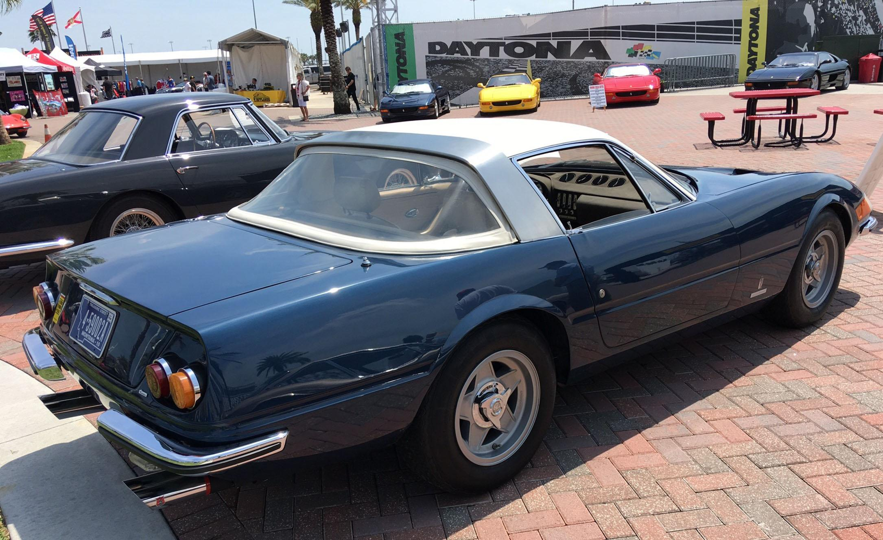
2017 Ferrari Club of America Major Award Winners 1969 365 GTB/4 Speciale s/n 12925, Luigi Chinetti Memorial Award for Outstanding Ferrari Road Car (foreground), 1960 250 GT Pinin Farina Coupe Series II s/n 1747 GT, National Vintage Preservation Award for Best Preserved Ferrari Pre-1980 (background).

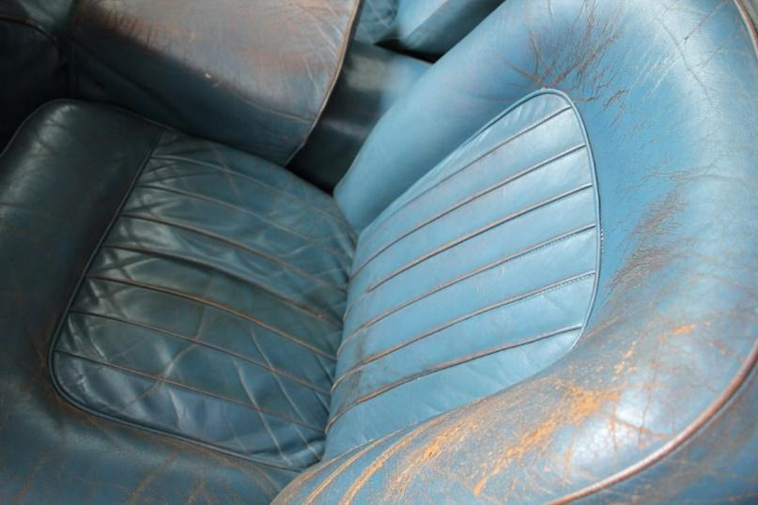1. Worn seats with original dye. 250 Coupe. Image David Eichenbaum
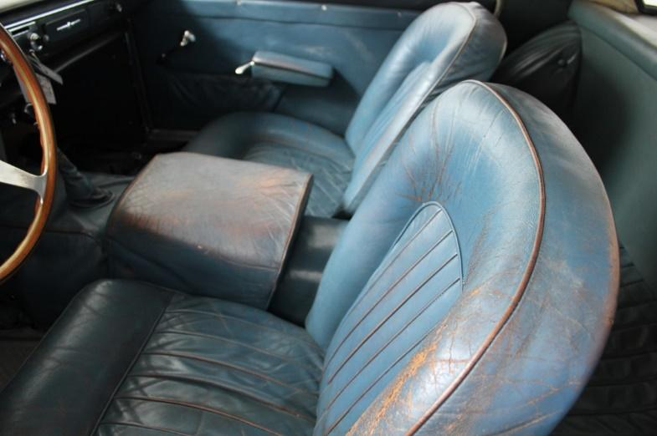
2. Worn seats with original dye. 250 Coupe. Image David Eichenbaum

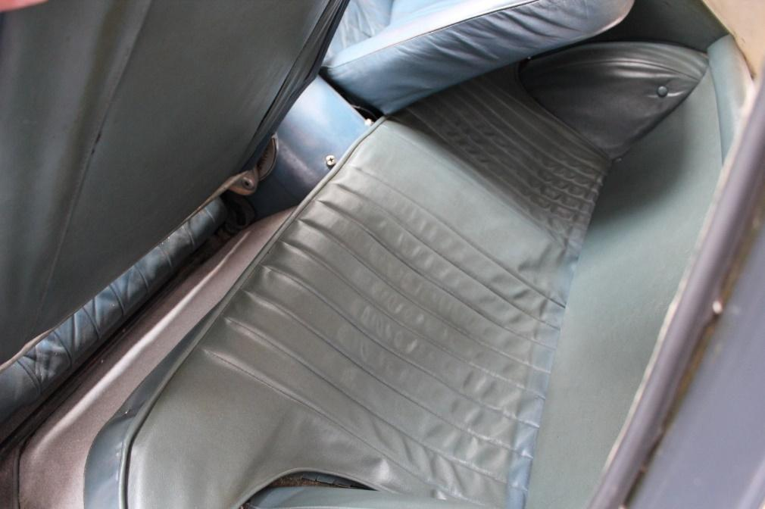
3. Worn original vinyl, pleats and piping. 250 Coupe. Image David Eichenbaum

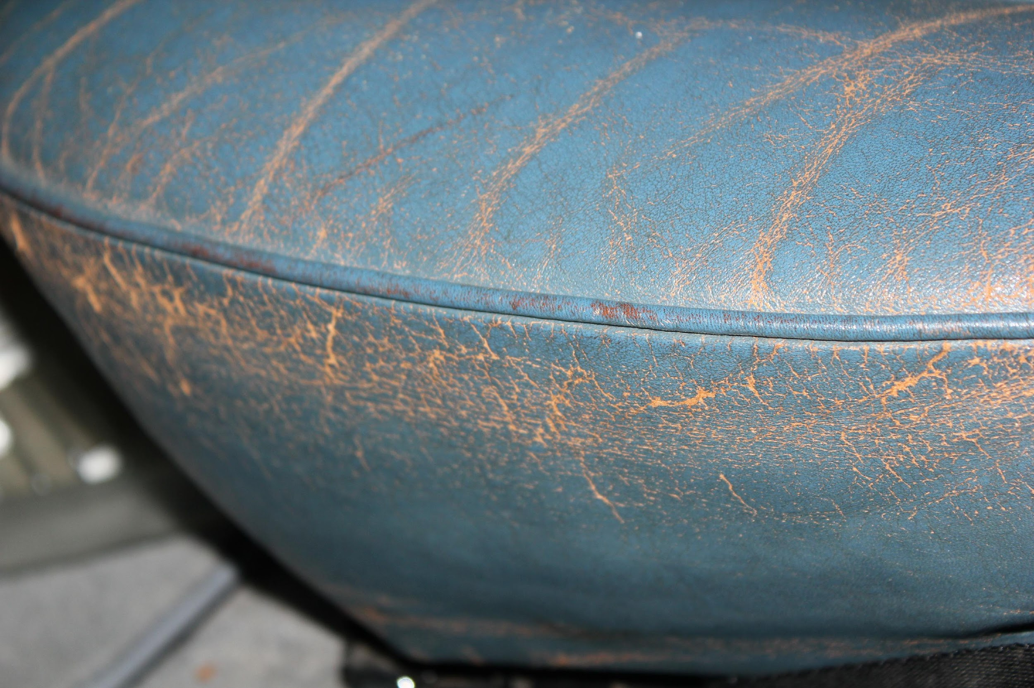
4. Detail of original leather dye and piping with original material underneath. 250 Coupe. Image David Eichenbaum

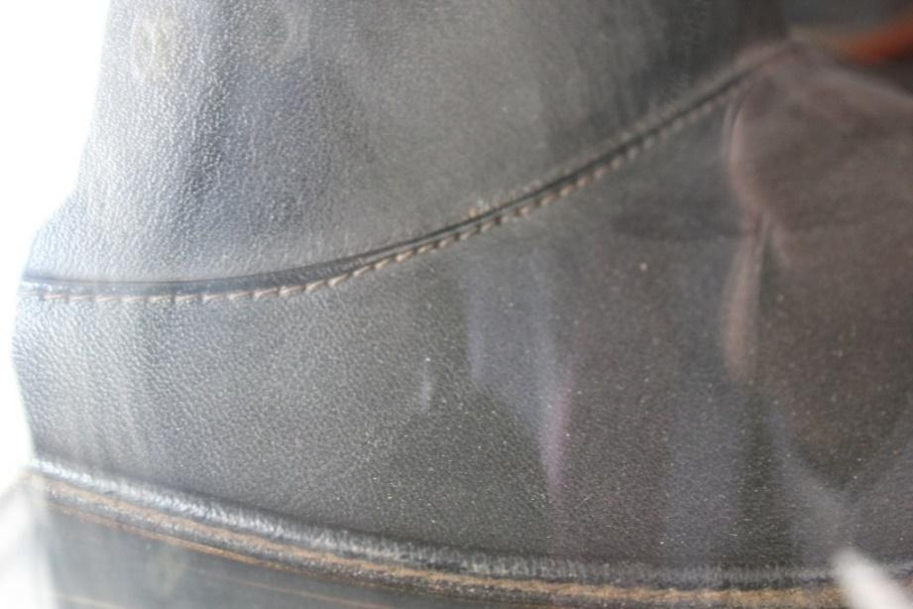
5. Original seats show grain, piping, stitching and workmanship. 250 Coupe. Image David Eichenbaum
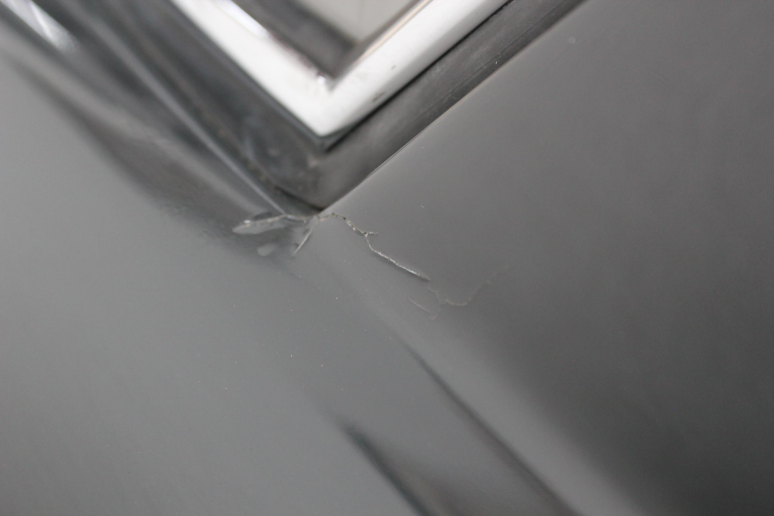
6. Typical cracking in older lacquer paint. 250 Coupe. David Eichenbaum

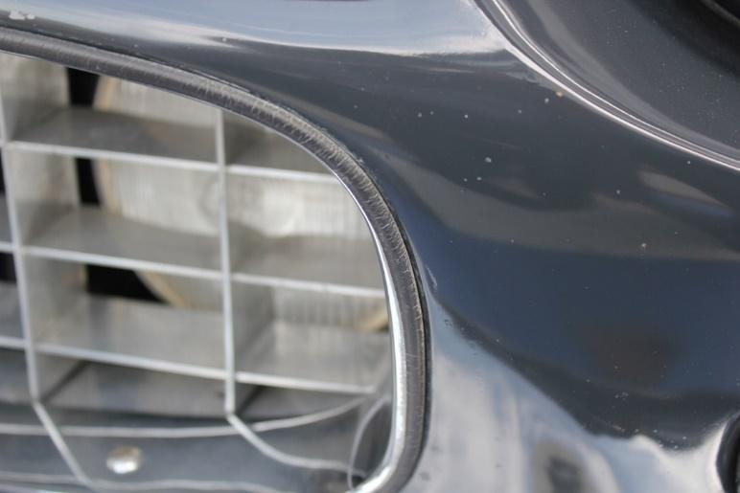7. Molding showing wear still performs original function. 250 Coupe. Image David Eichenbaum

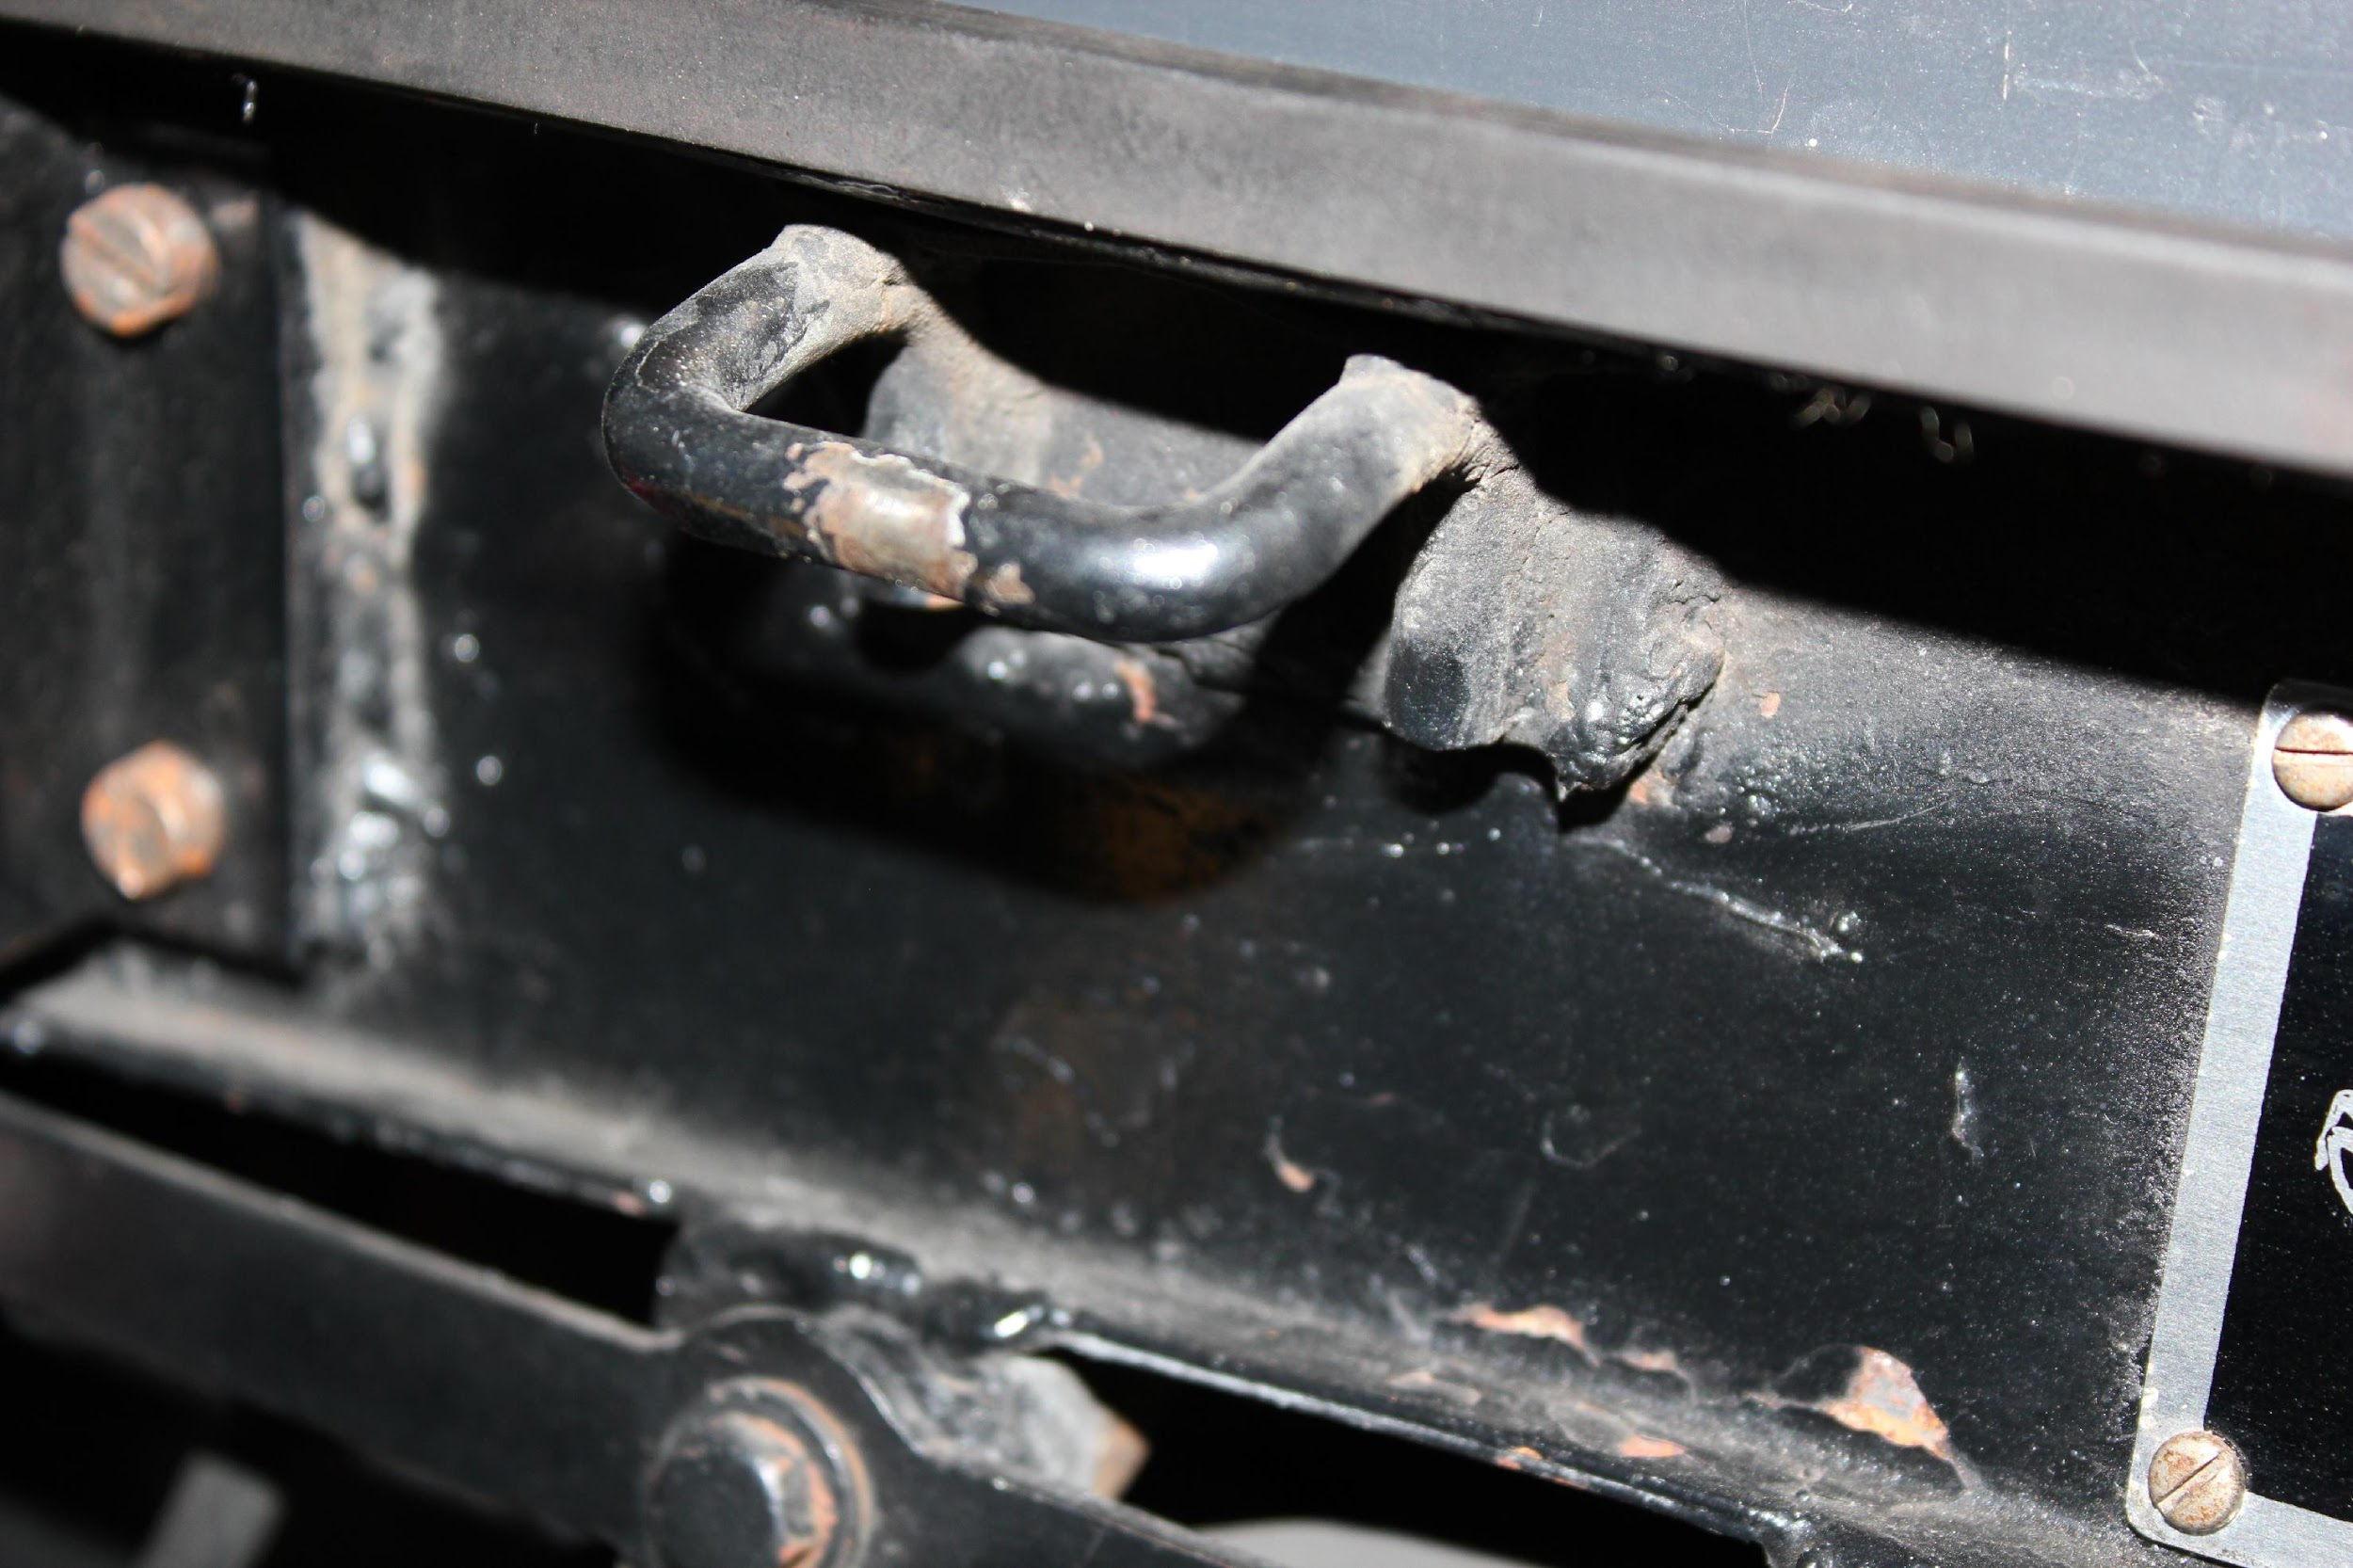
8. Hood latch originally painted over with welded latch and evidence of use. 250 Coupe. Image David Eichenbaum
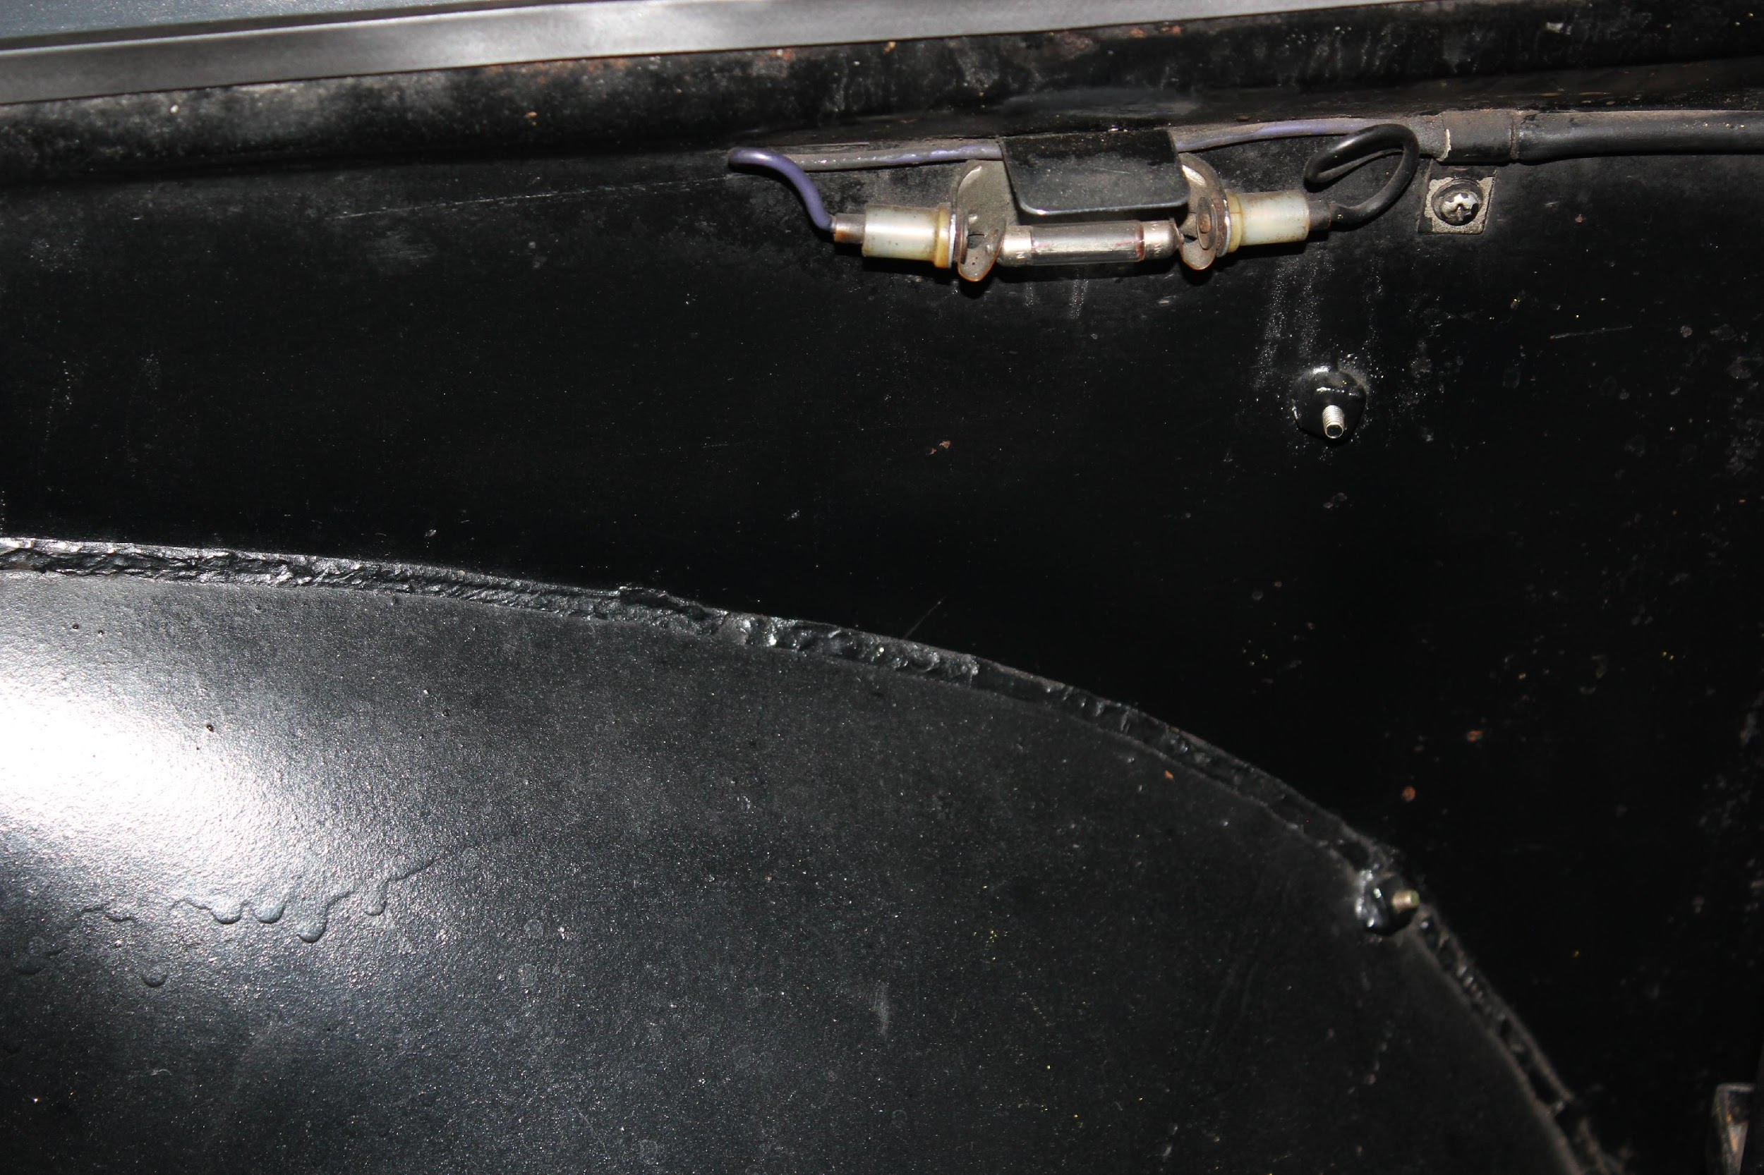
9. As built wiring and interior light with rough weld and run in inner fender paint. 250 Coupe. Image David Eichenbaum

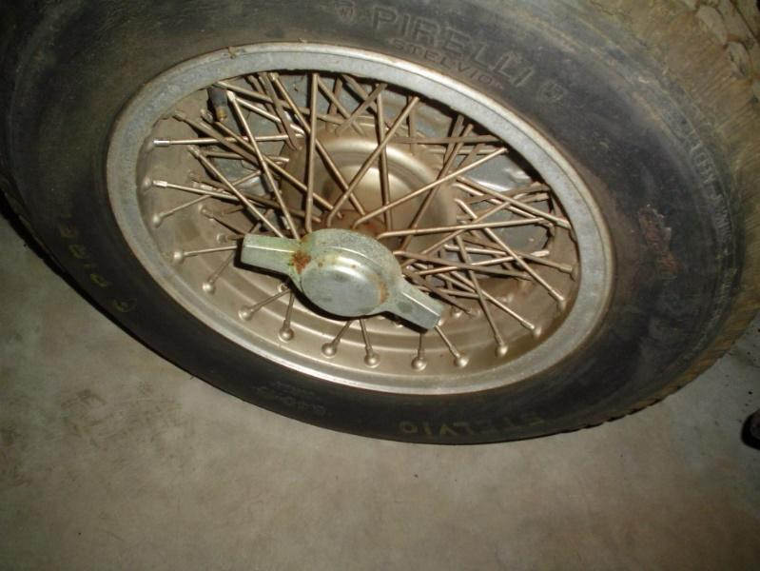
10. Early wheel still represents original configuration and finish. 250 Europa. Image David Carte
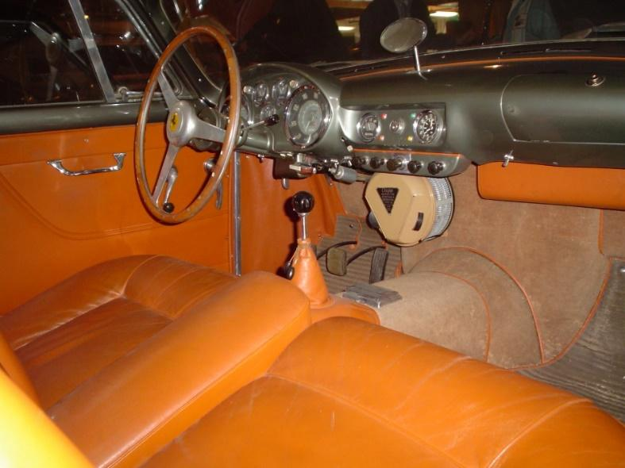
11. Original door skins, carpets, heel pads, piping, tassels, heater and dash. 250 Europa. Image David Carte
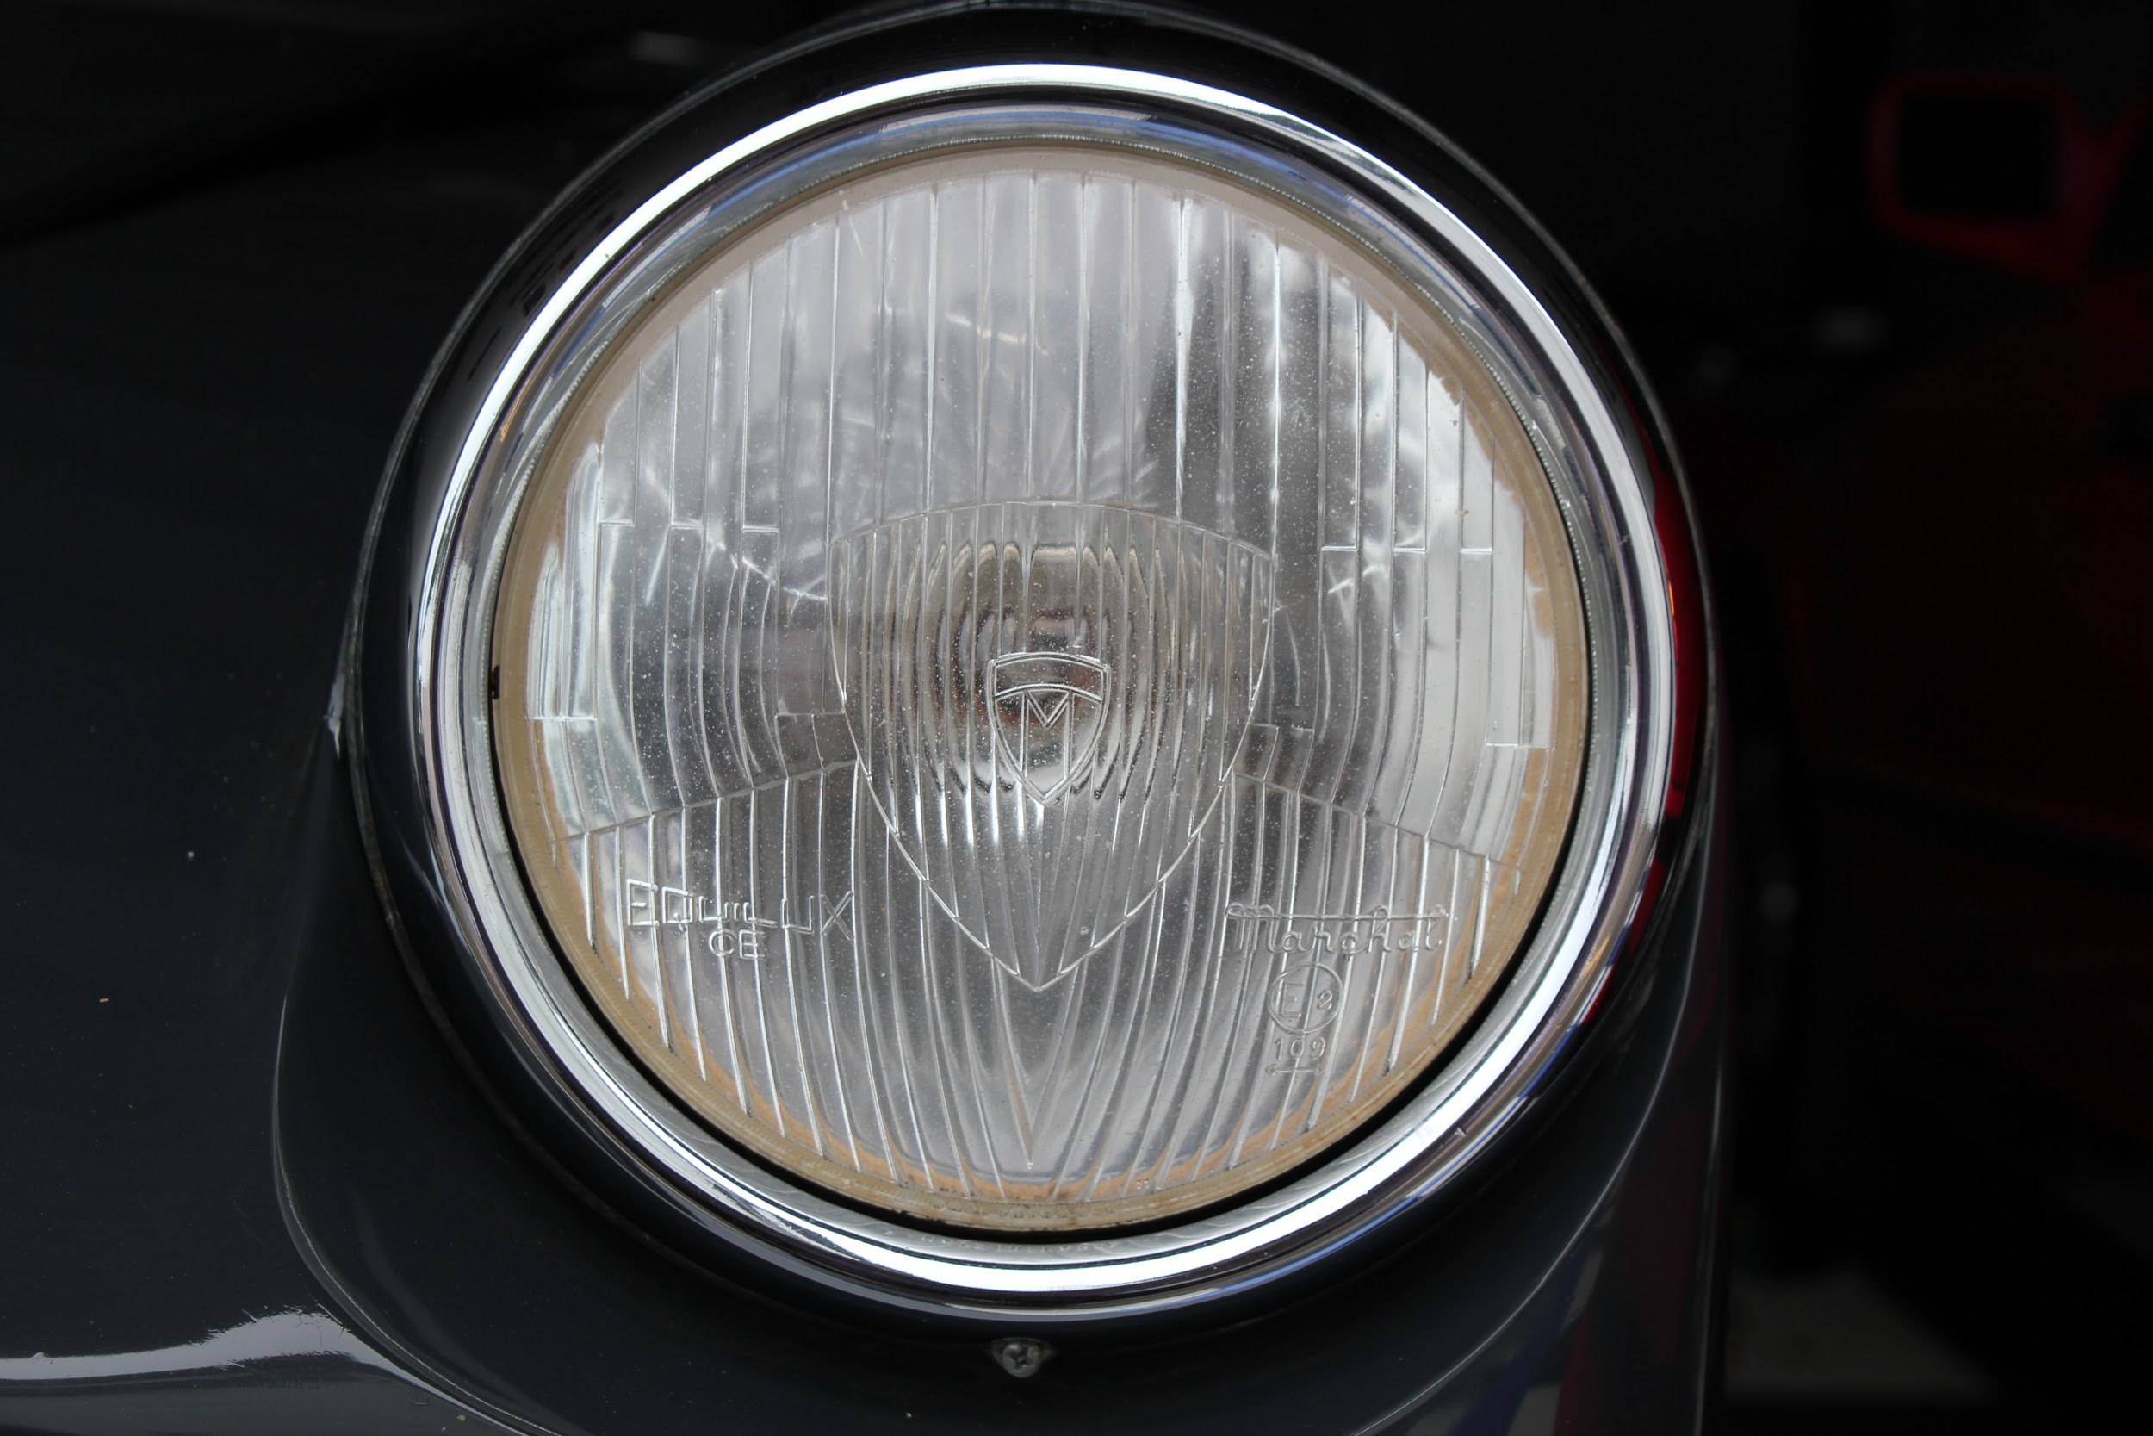
12. Marchal headlight with patina consistent with cars vintage. 250 Coupe. Image David Eichenbaum
.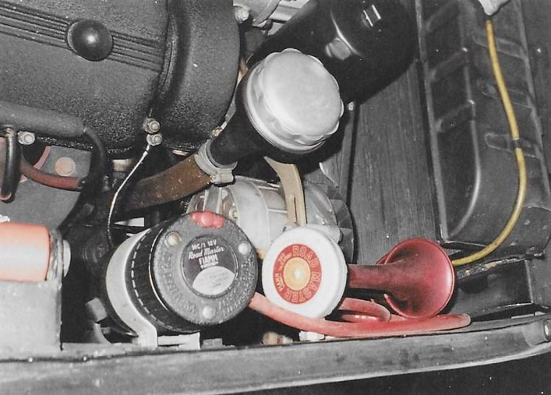
13. Typical unrestored engine details – except for painted filter. 250 GT Lusso. Image David Carte
.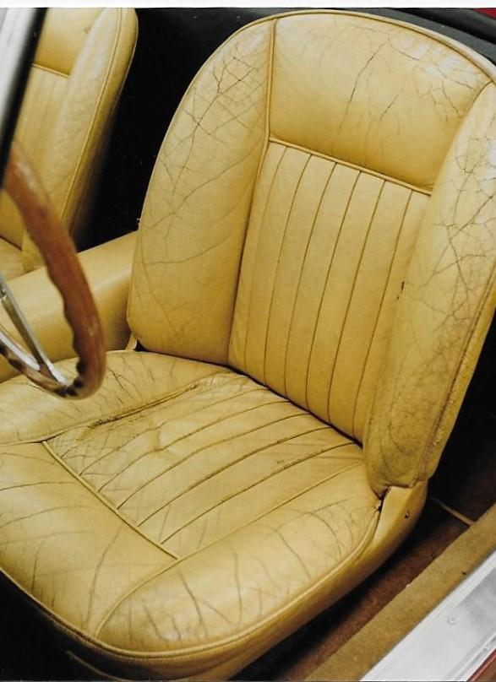
14. Serviceable seat with minor tear. 250 Cabriolet. Image David Carte

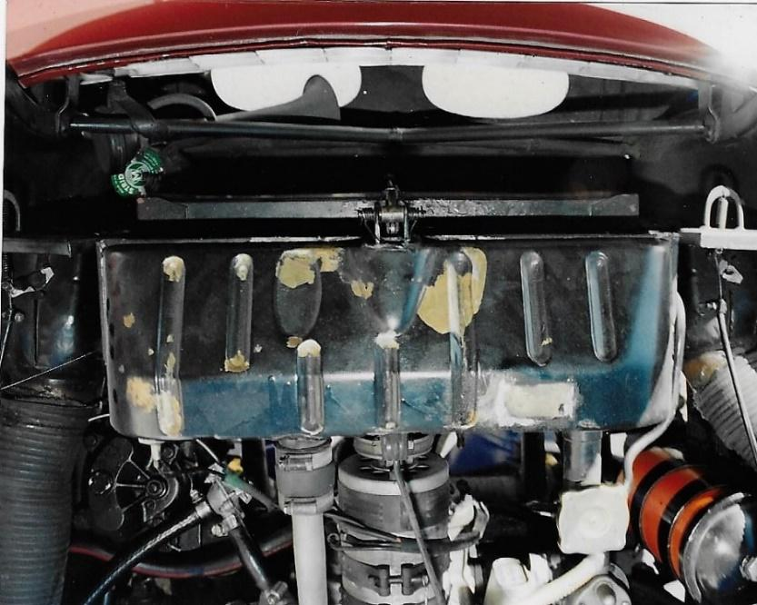
15. Weathered radiator functioning as original. 250 Cabriolet. Image David Carte

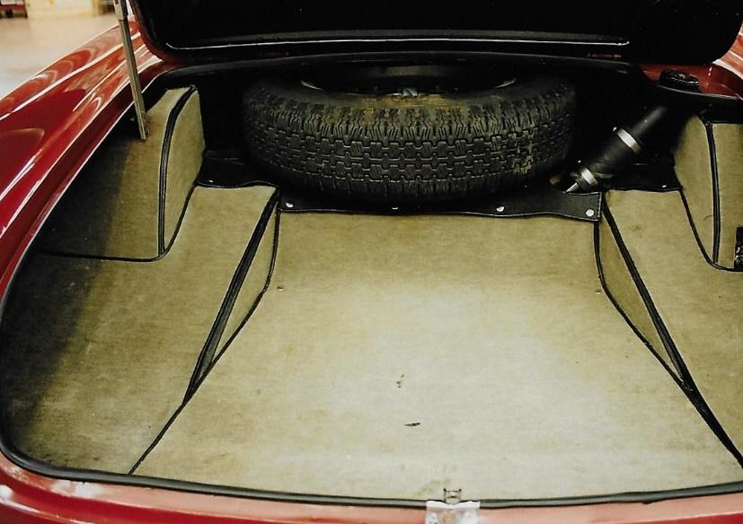
16. Original trunk and carpeting. Modern clamps and tire. Missing wiring block cover. 250 Cabriolet. Image David Carte
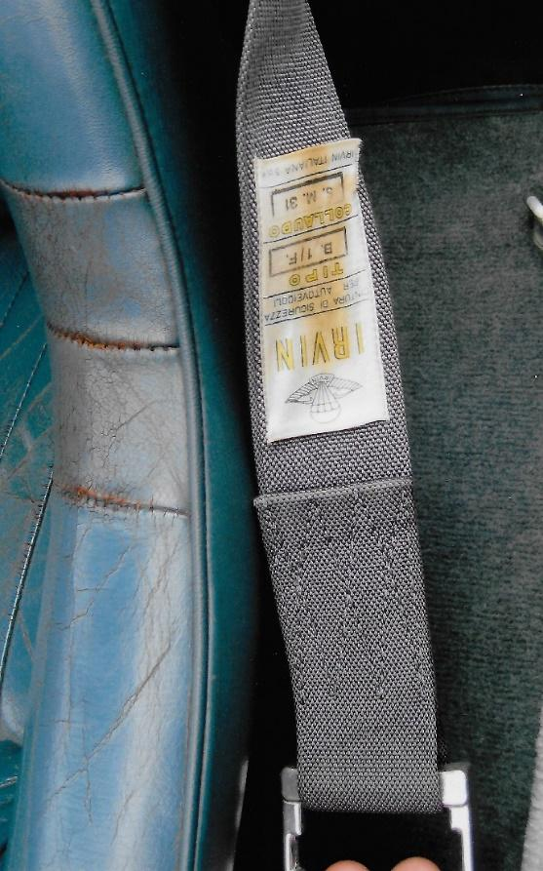
17. Seat and period belt. 250 Lusso. Image David Carte

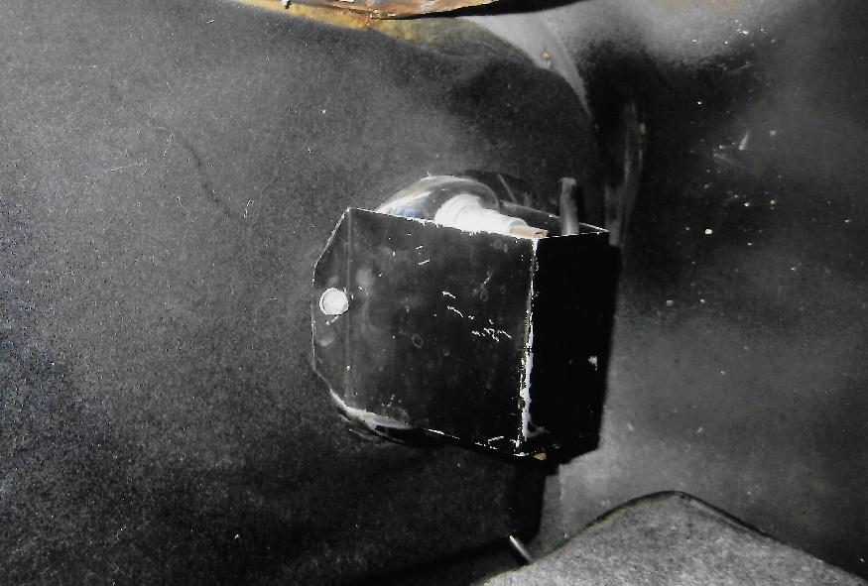
18. Inside trunk worn from use but serviceable. 250 Lusso. Image David Carte
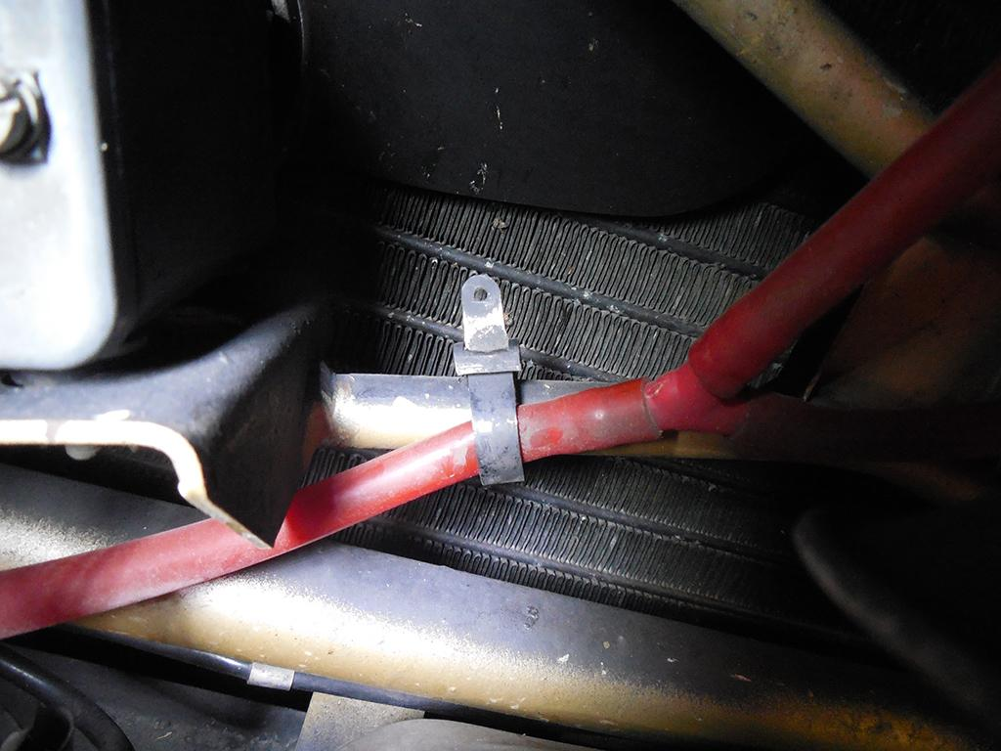
19. Black overspray on body-colored frame expected as inner fenders were likely sprayed from rear before radiator and engine were installed. 330 GTC. Image Tom Yang

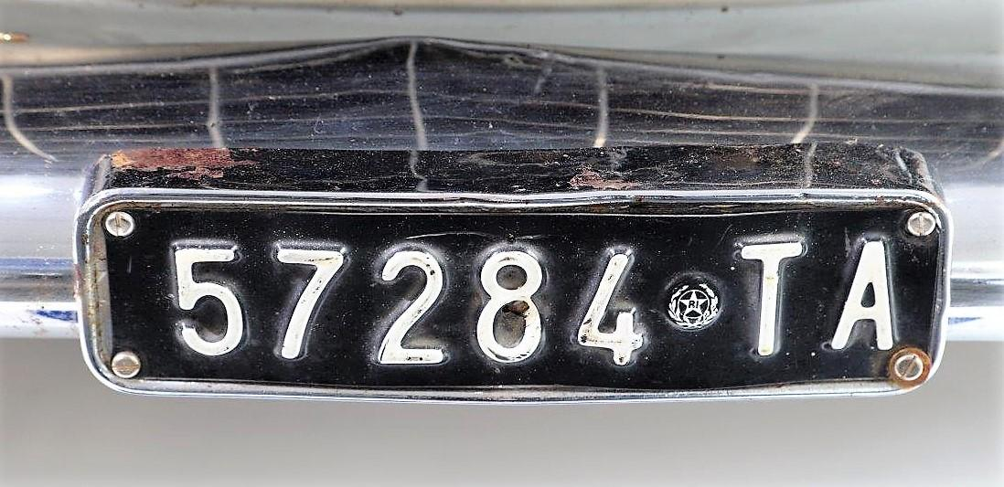
20. Front license plate frame – rough but original. 250 Europa. Image David Carte
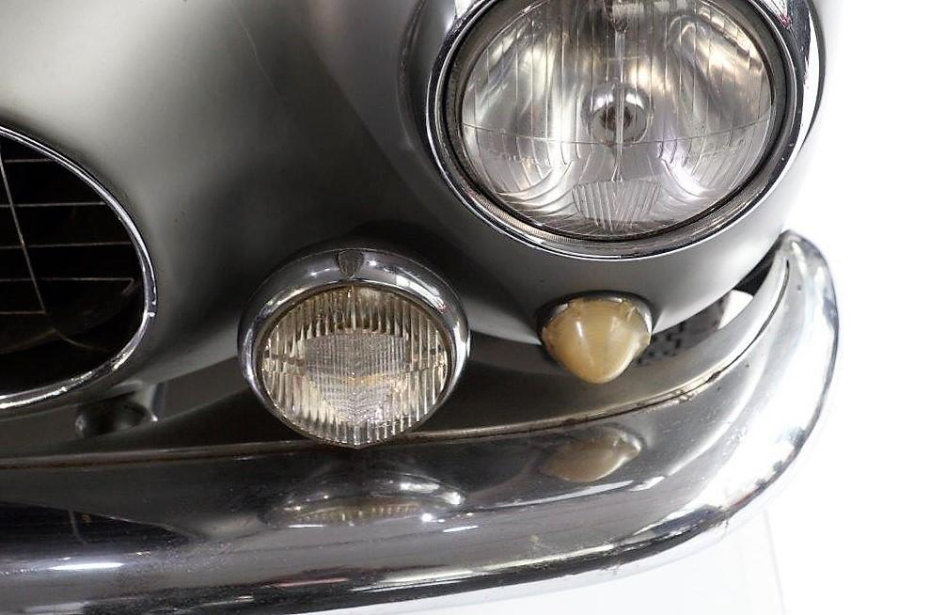
21. Dull chrome and slight blemishes on bumper. 250 Europa. Image David Carte
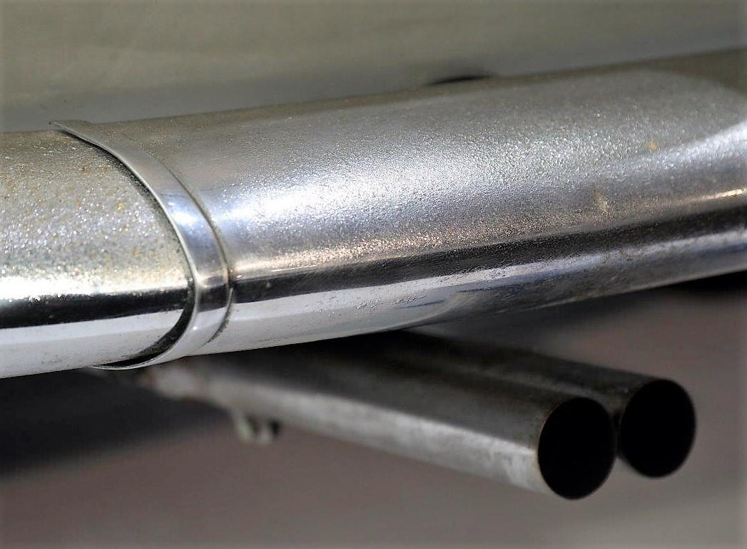
22. Weathering chrome still intact. 250 Europa. Image David Carte

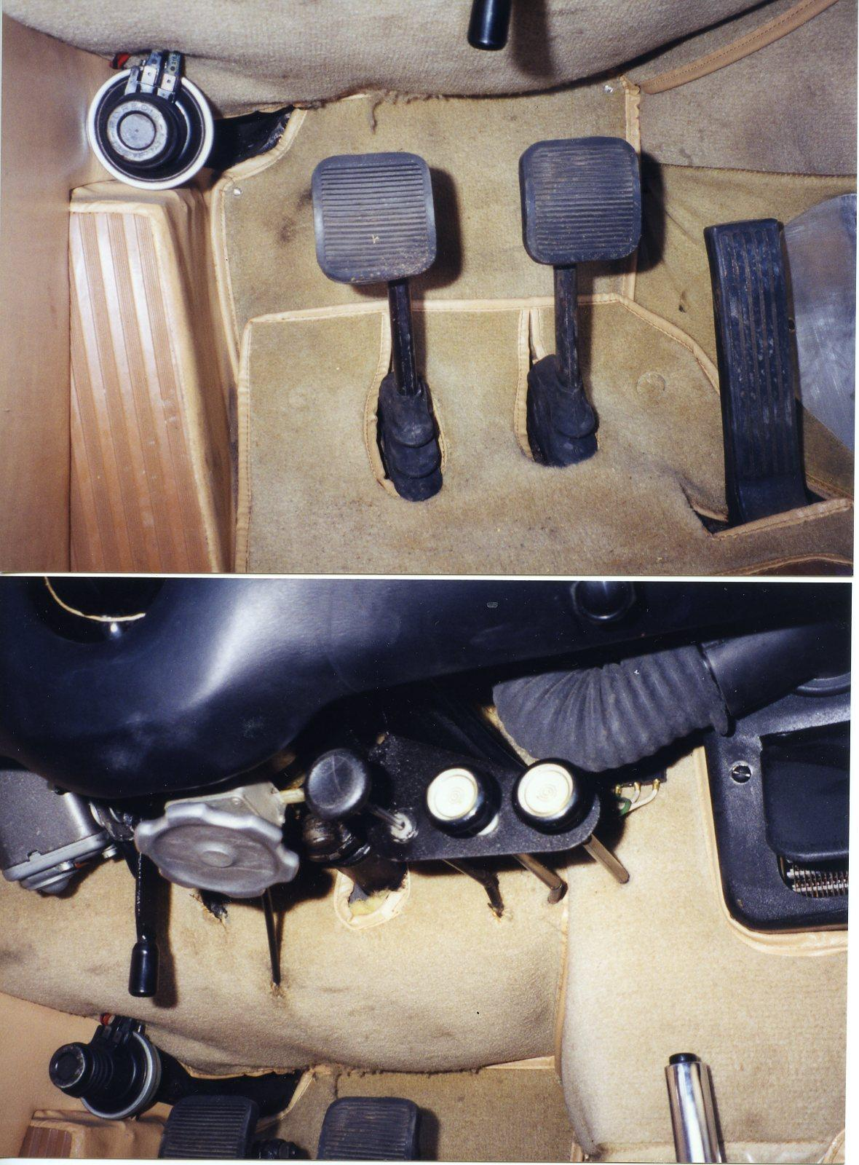

23. Rough fit, uneven stitching and untrimmed cut-outs reflect typical Scaglietti practice. 250 Lusso. Image David Carte
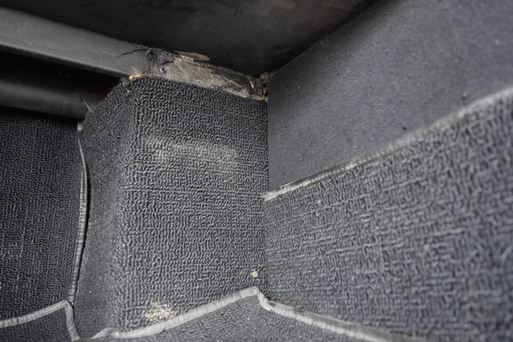
24. Trunk carpet, untrimmed as built with glue overlap on frame. 246 Dino. Image Marco Hartner.
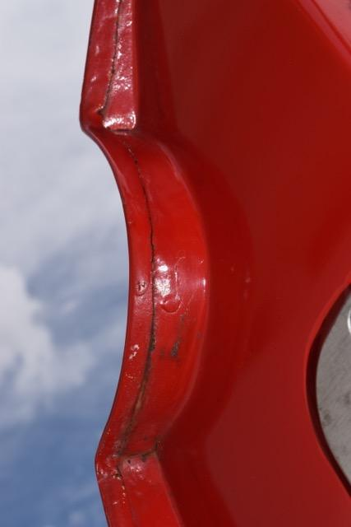
25. Typical rough door-jamb craftsmanship and paint blems. 246 Dino. Image Marco Hartner

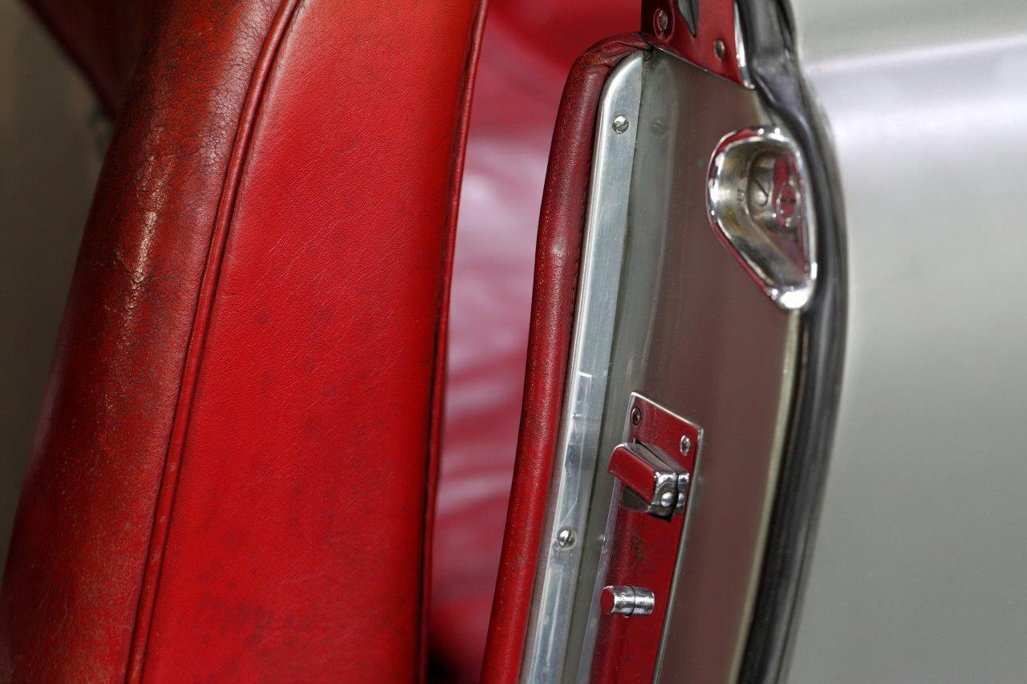
26. Unrestored interior with original door jamb chrome and rubber seal. 250 Europa. Image David Carte
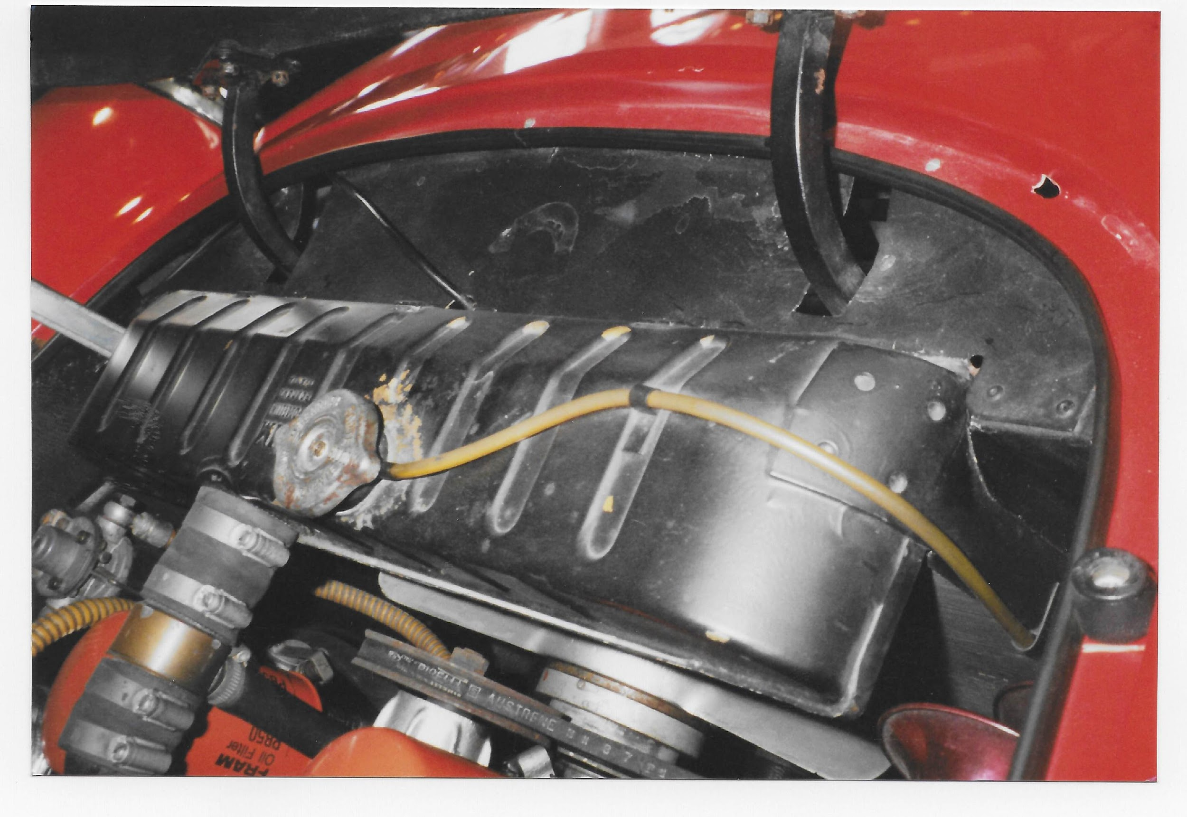
27. Weathered original details but belt probably replaced (acceptable). 250 Lusso. Image David Carte
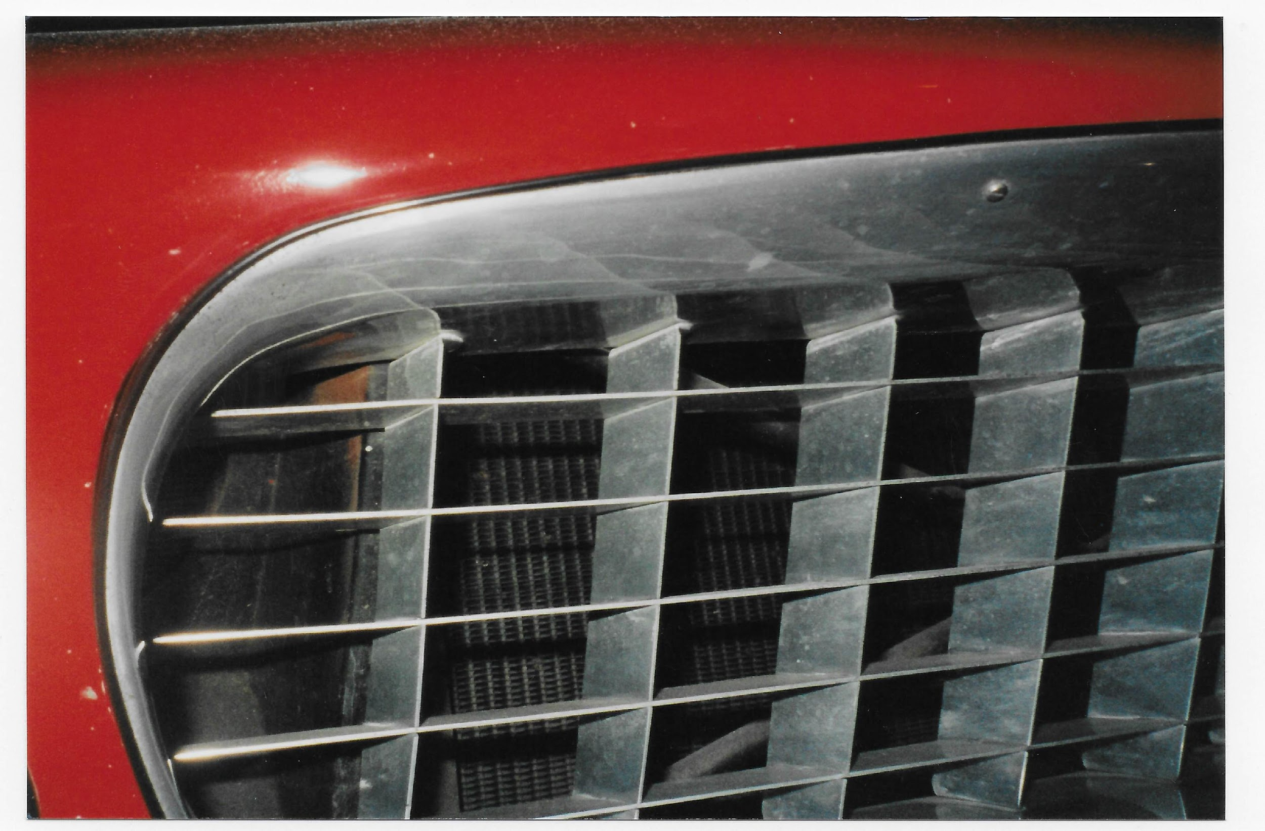
28. Original grill surround, still intact and functional. 250 Lusso. Image David Carte
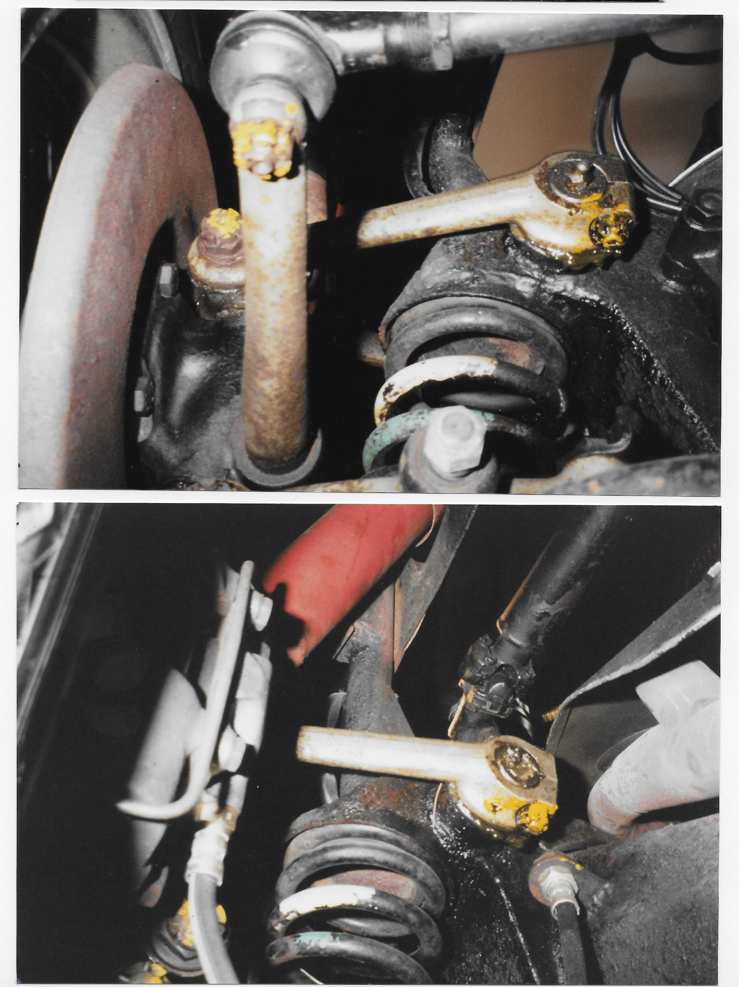
29. As-built suspension with yellow tightening marks intact. 250 Lusso. Image David Carte

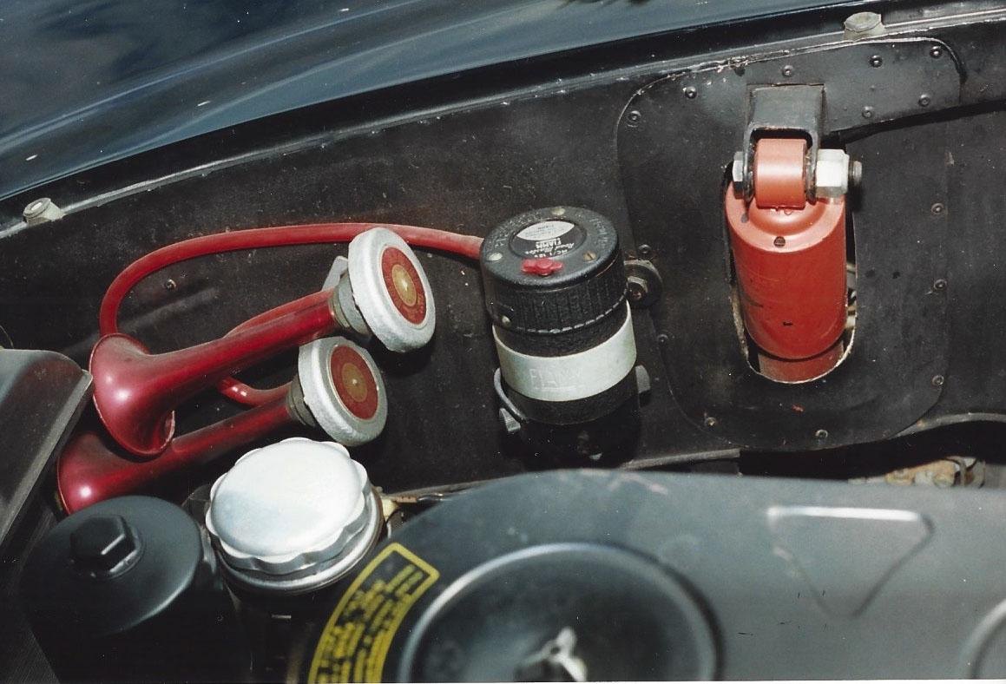
30. Typical original Lusso engine compartment except repainted oil filter. Note rivets, logos, horns. 250 Lusso. Image Greg Jones
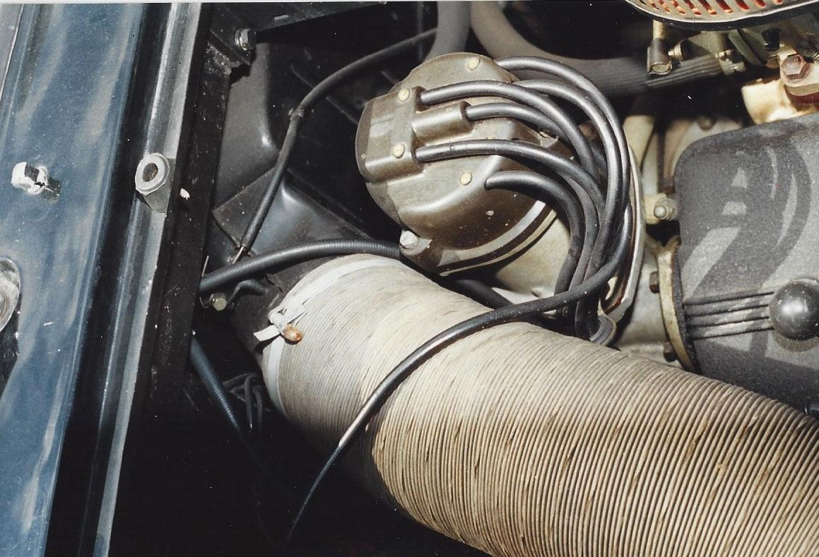
31. Original washer nozzles, paper air hose with Copiglias and other details.. 250 Lusso. Image Greg Jones
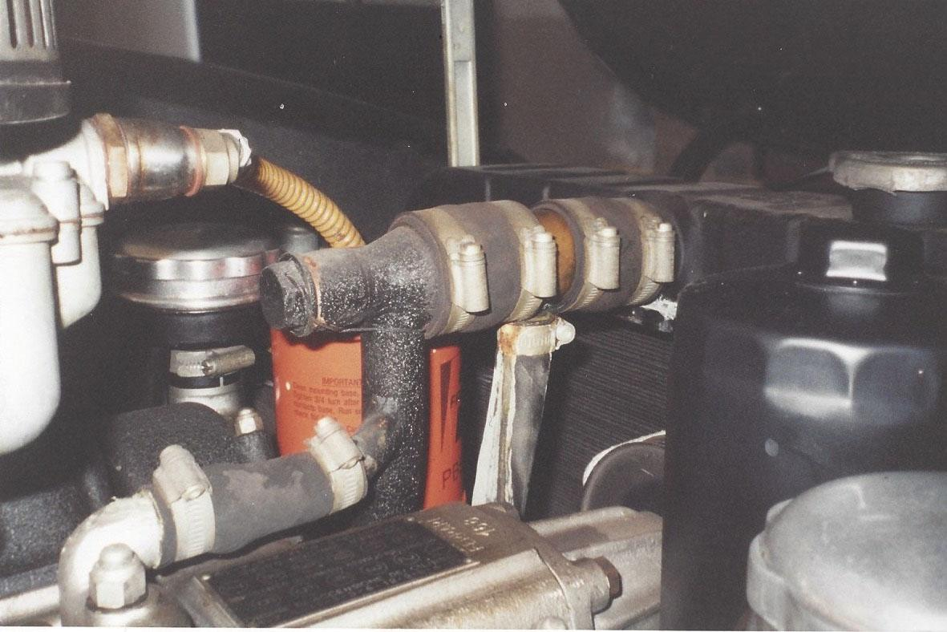
32. Typical use of Cheney clamps. 250 Lusso. Image Greg Jones
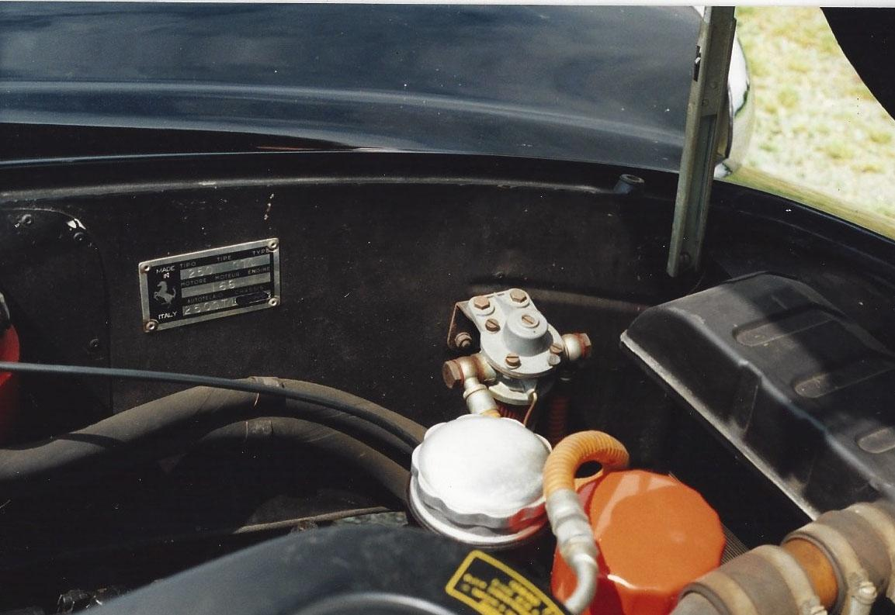
33. Multiple original details for reference. 250 Lusso. Image Greg Jones

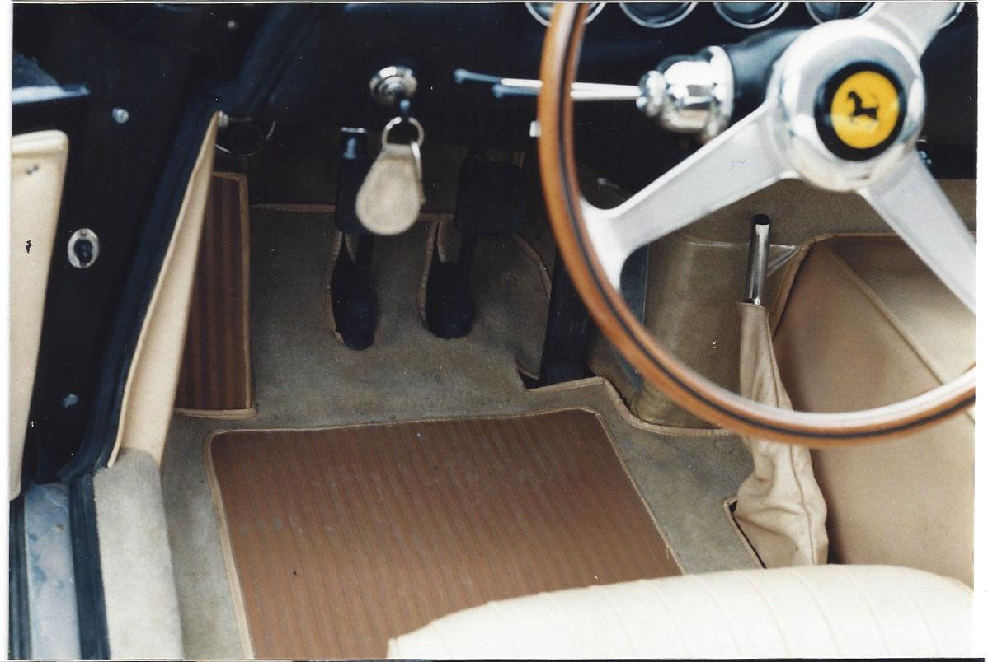
34. Typical interior. Note brake boot, heel pads, keyfob. 250 Lusso. Image Greg Jones
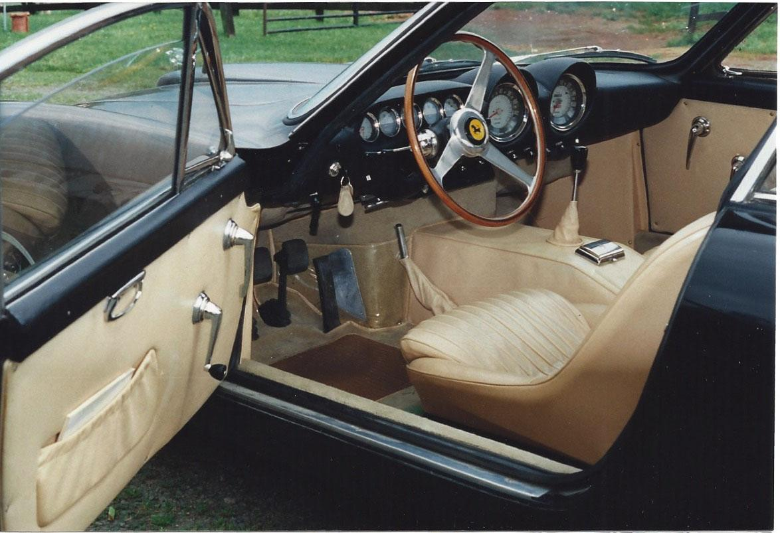
35. Original interior,puckered door pocket and console and plastic scuff guard. 250 Lusso. Image Greg Jones
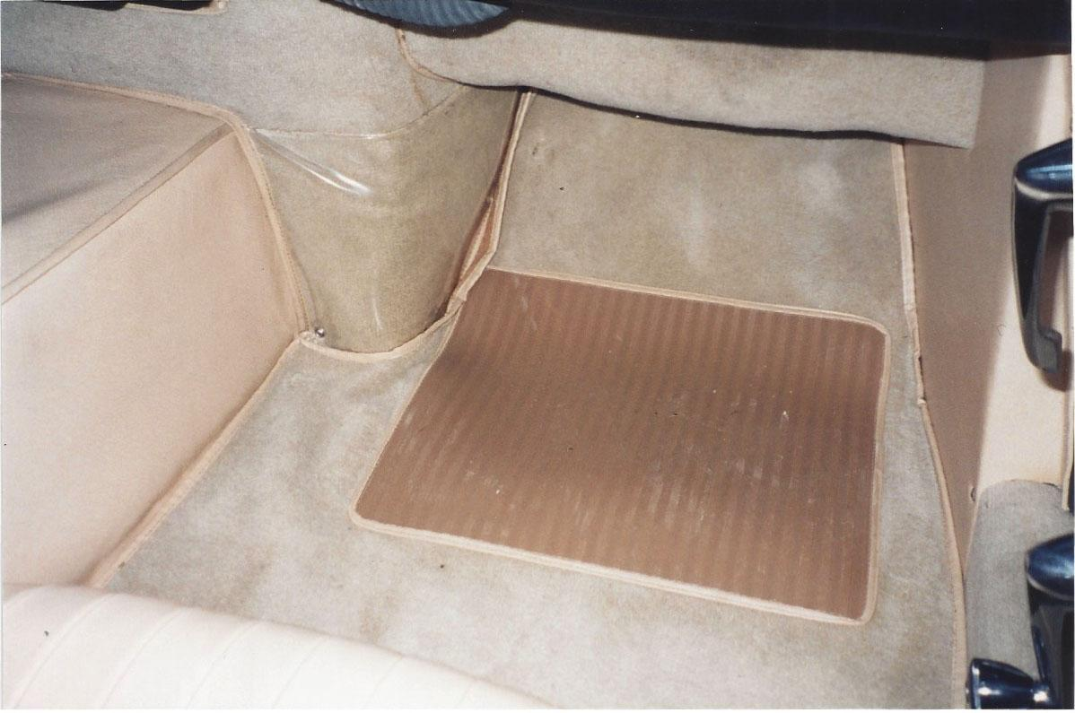
36. Plastic scuff guard, unevenly fitting vinyl bound mat. 250 Lusso. Images Greg Jones
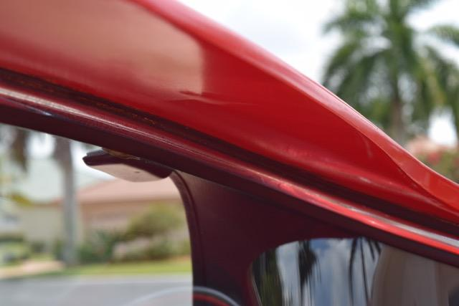
37. Typical factory paint blemish on door jam as delivered. 246 Dino. Image Marco Hartner 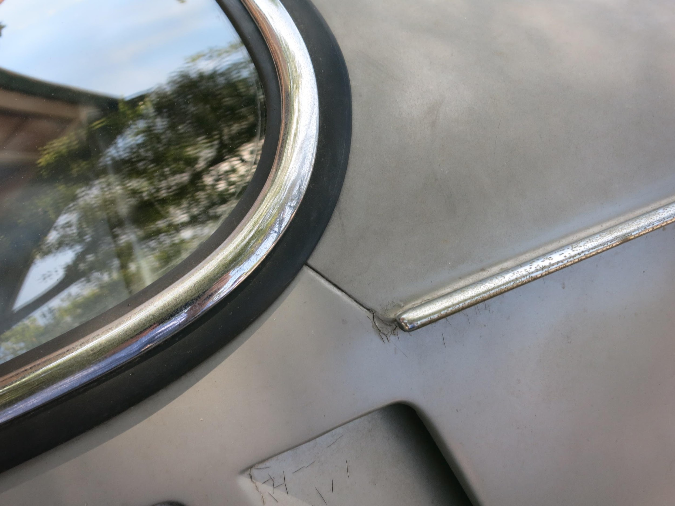38. Original glass, molding, paint and construction detail. 275 GTB Alloy. Image Donovan Leyden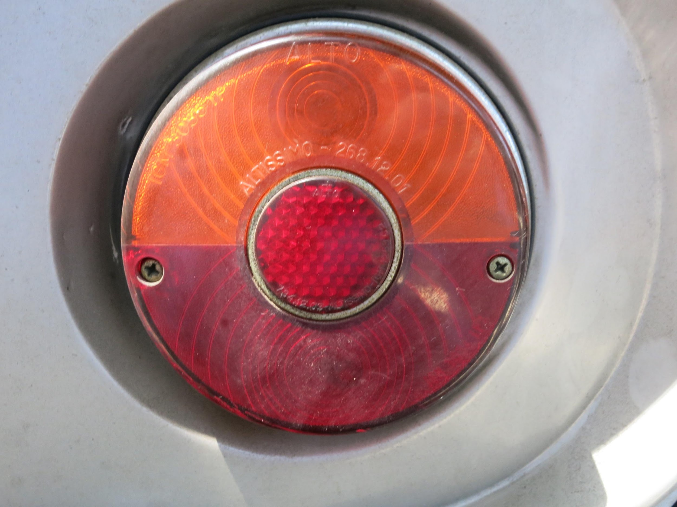
39. Aged tail light lens and screws with appropriate original patina. 275 GTB Alloy. Image Donovan Leyden
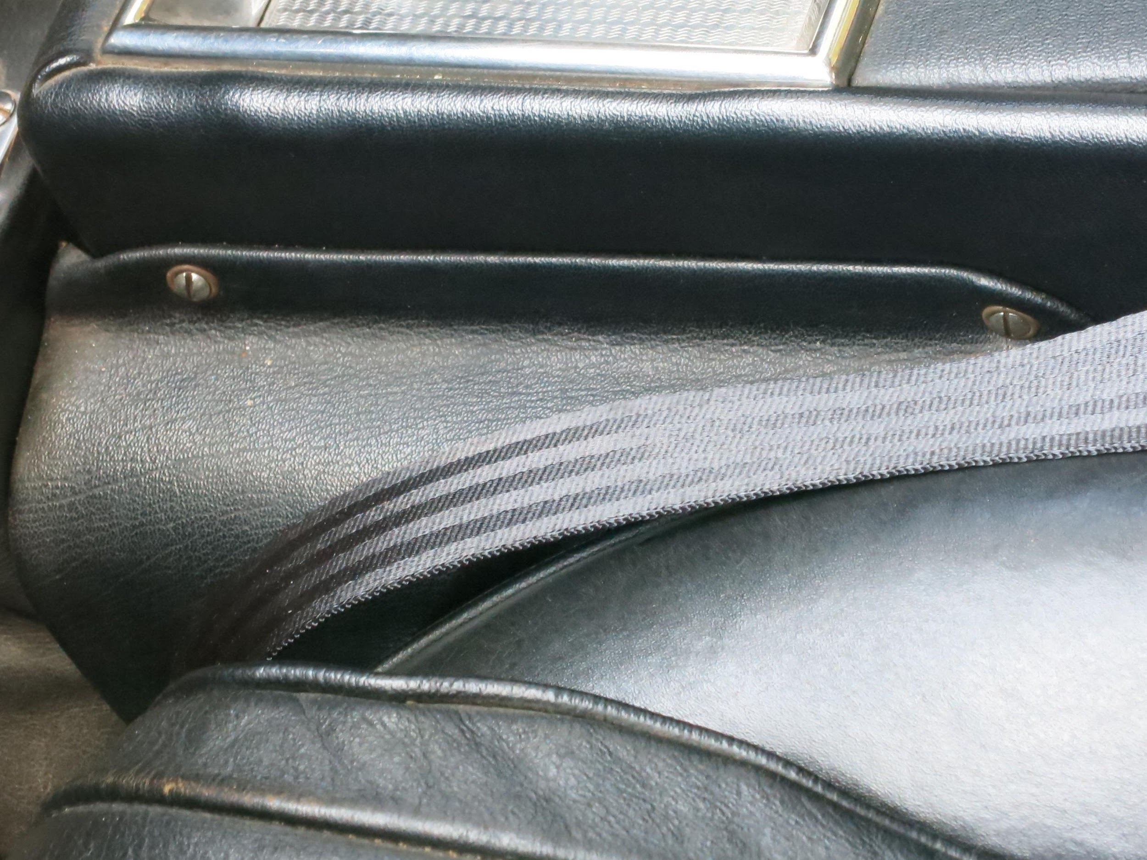
40. Seat and console materials, with original grain, hardware and lap belt. 275 GTB Alloy. Image Donovan Leyden
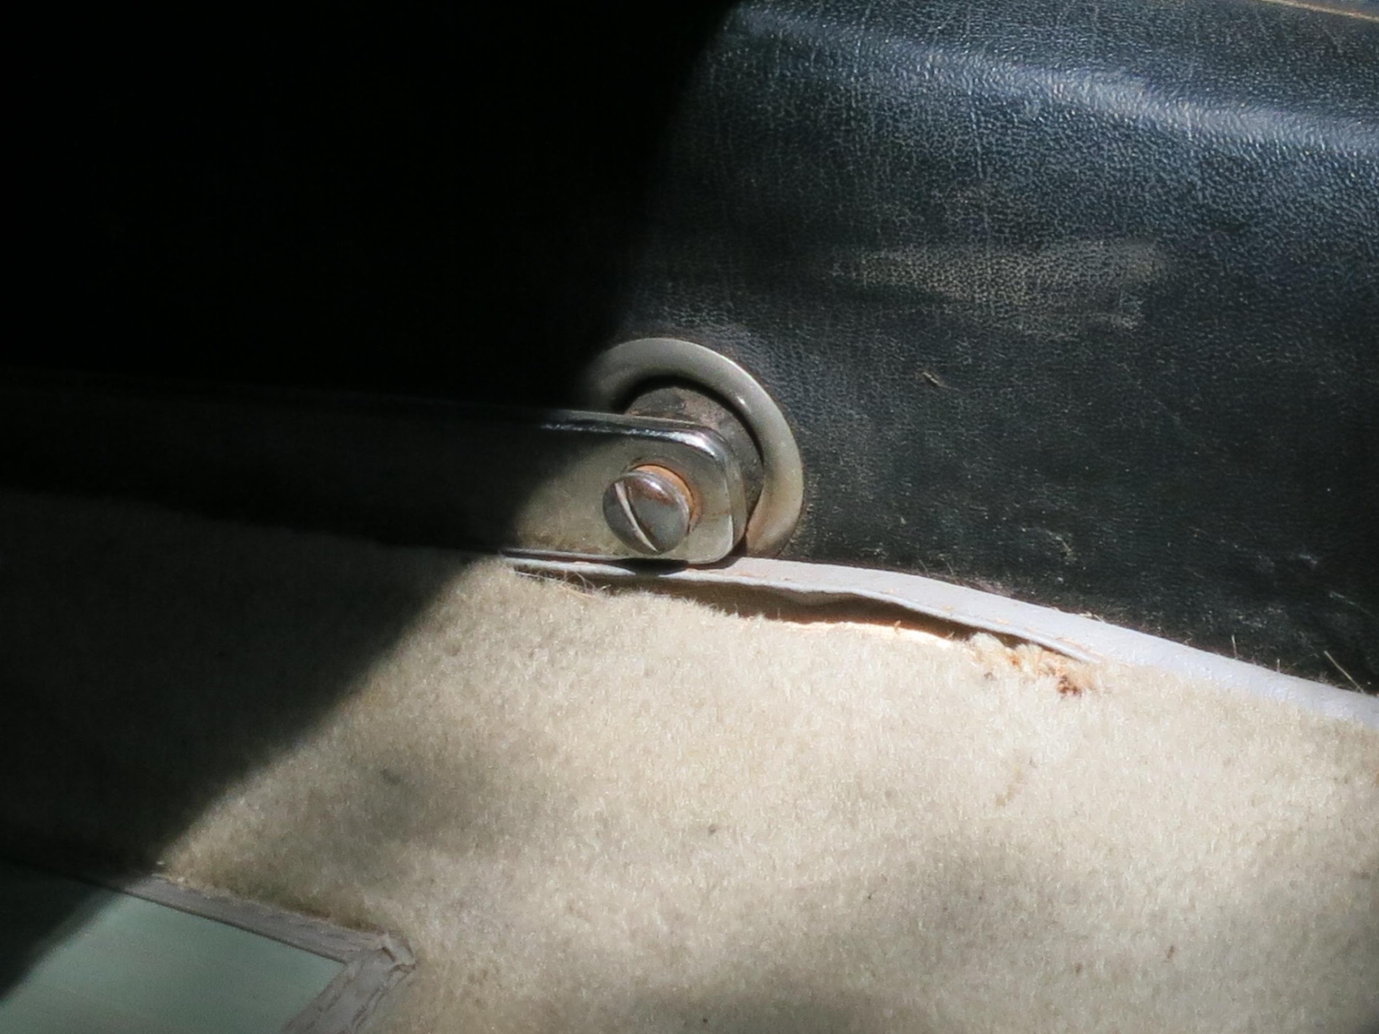
41. Note passenger footrest hardware, carpet weave, vinyl bound and stitched heel pad. 275 GTB Alloy. Image Donovan Leyden
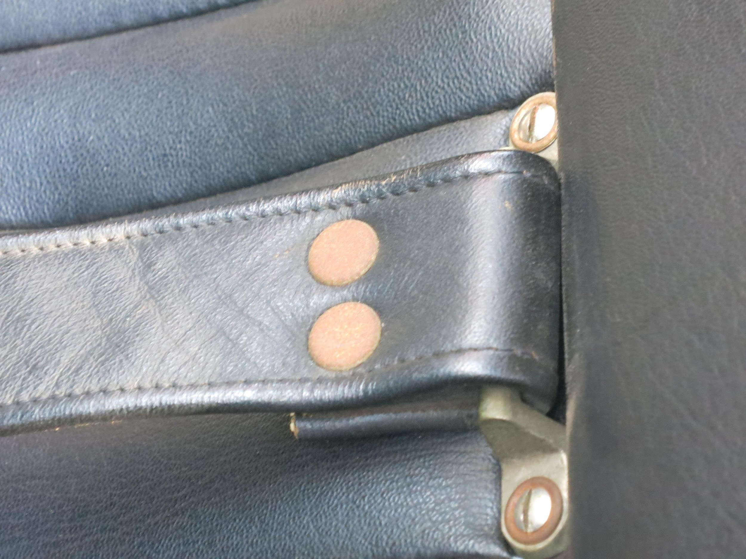
42. Luggage strap and upholstery texture, stitching and hardware. 275 GTB Alloy. Image Donovan Leyden
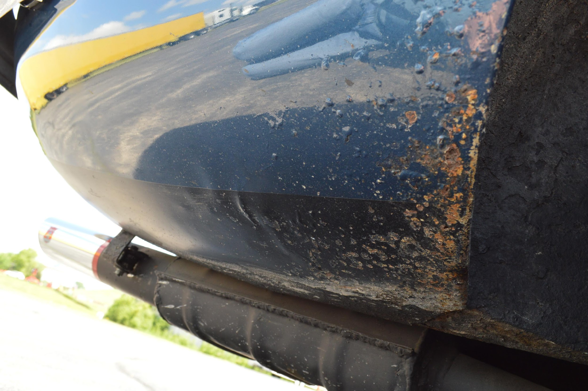
43. Original Daytona Speciale resonator with limited repair (welded cap). Owner resisted temptation to repaint despite some surface rust. Daytona Speciale. Image Dustin Wetmore
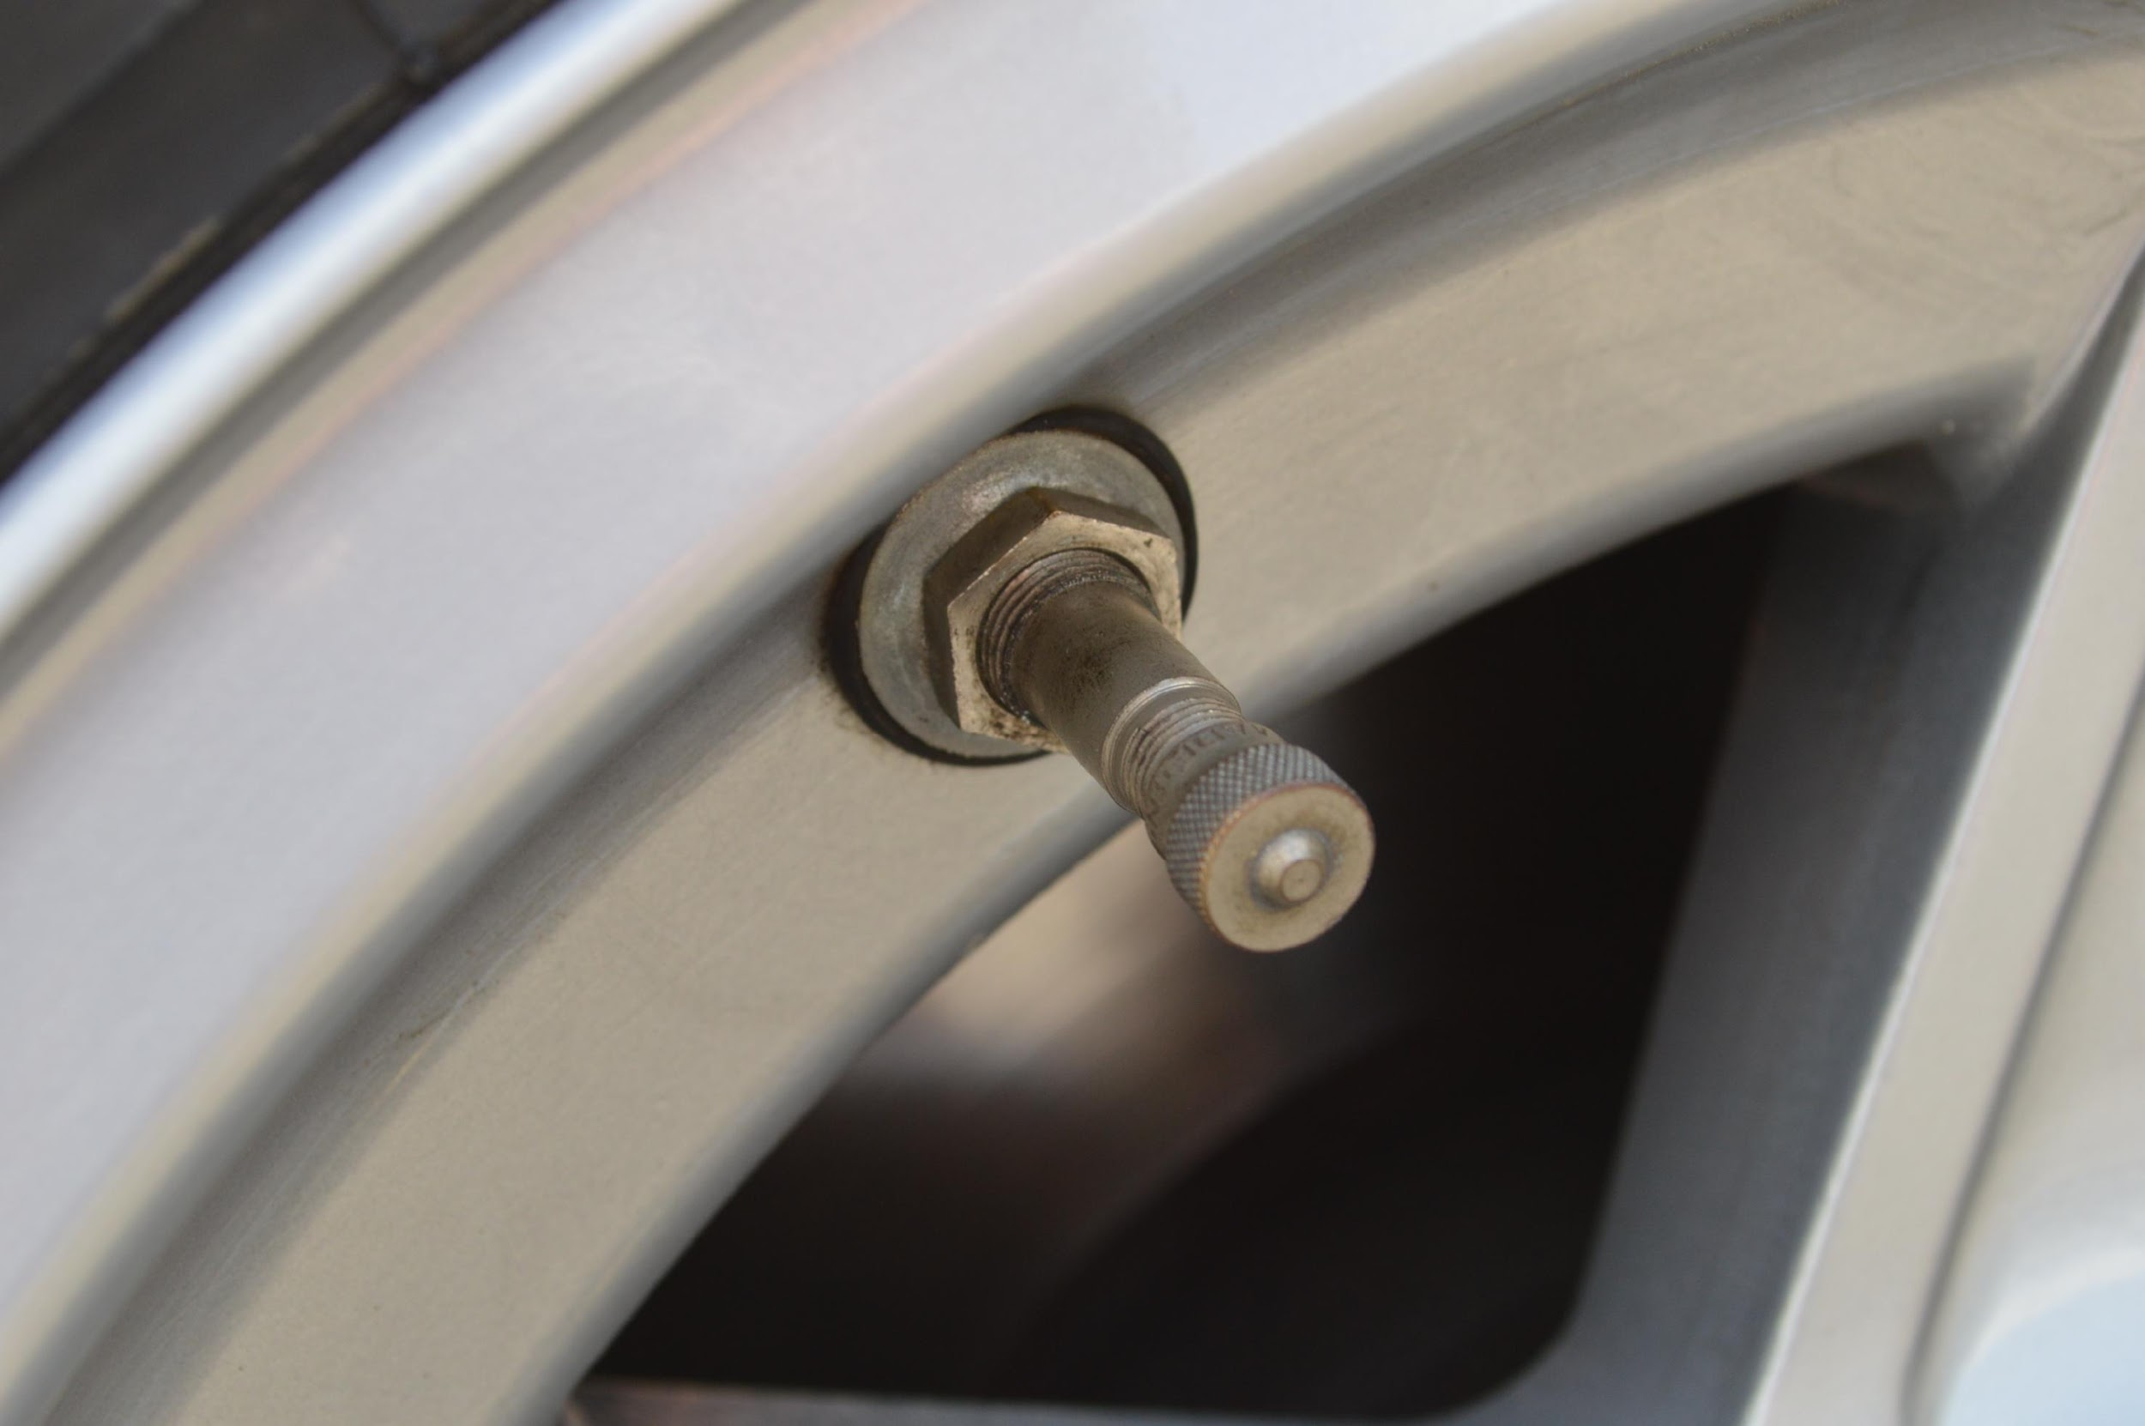
44. Serviceable Michelin XWX tube sleeve. Daytona Speciale. Image Dustin Wetmore
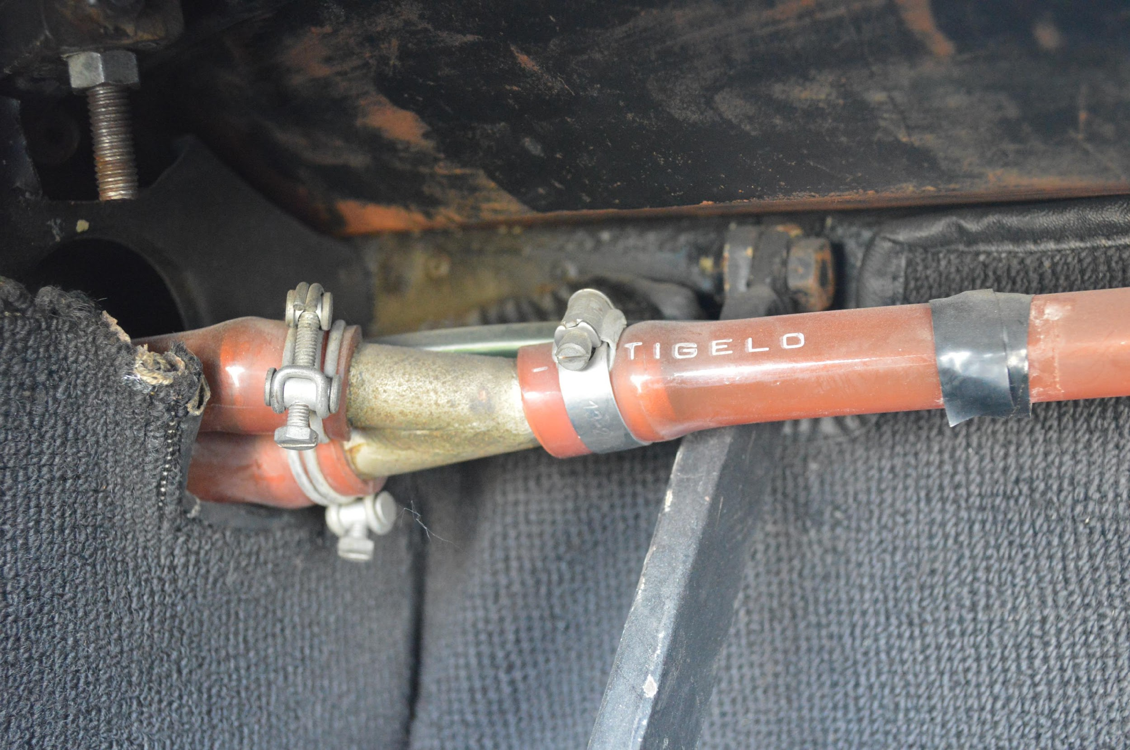45. Unmolested original trunk, fuel vapor hose and clamps. Daytona Speciale. Image Dustin Wetmore
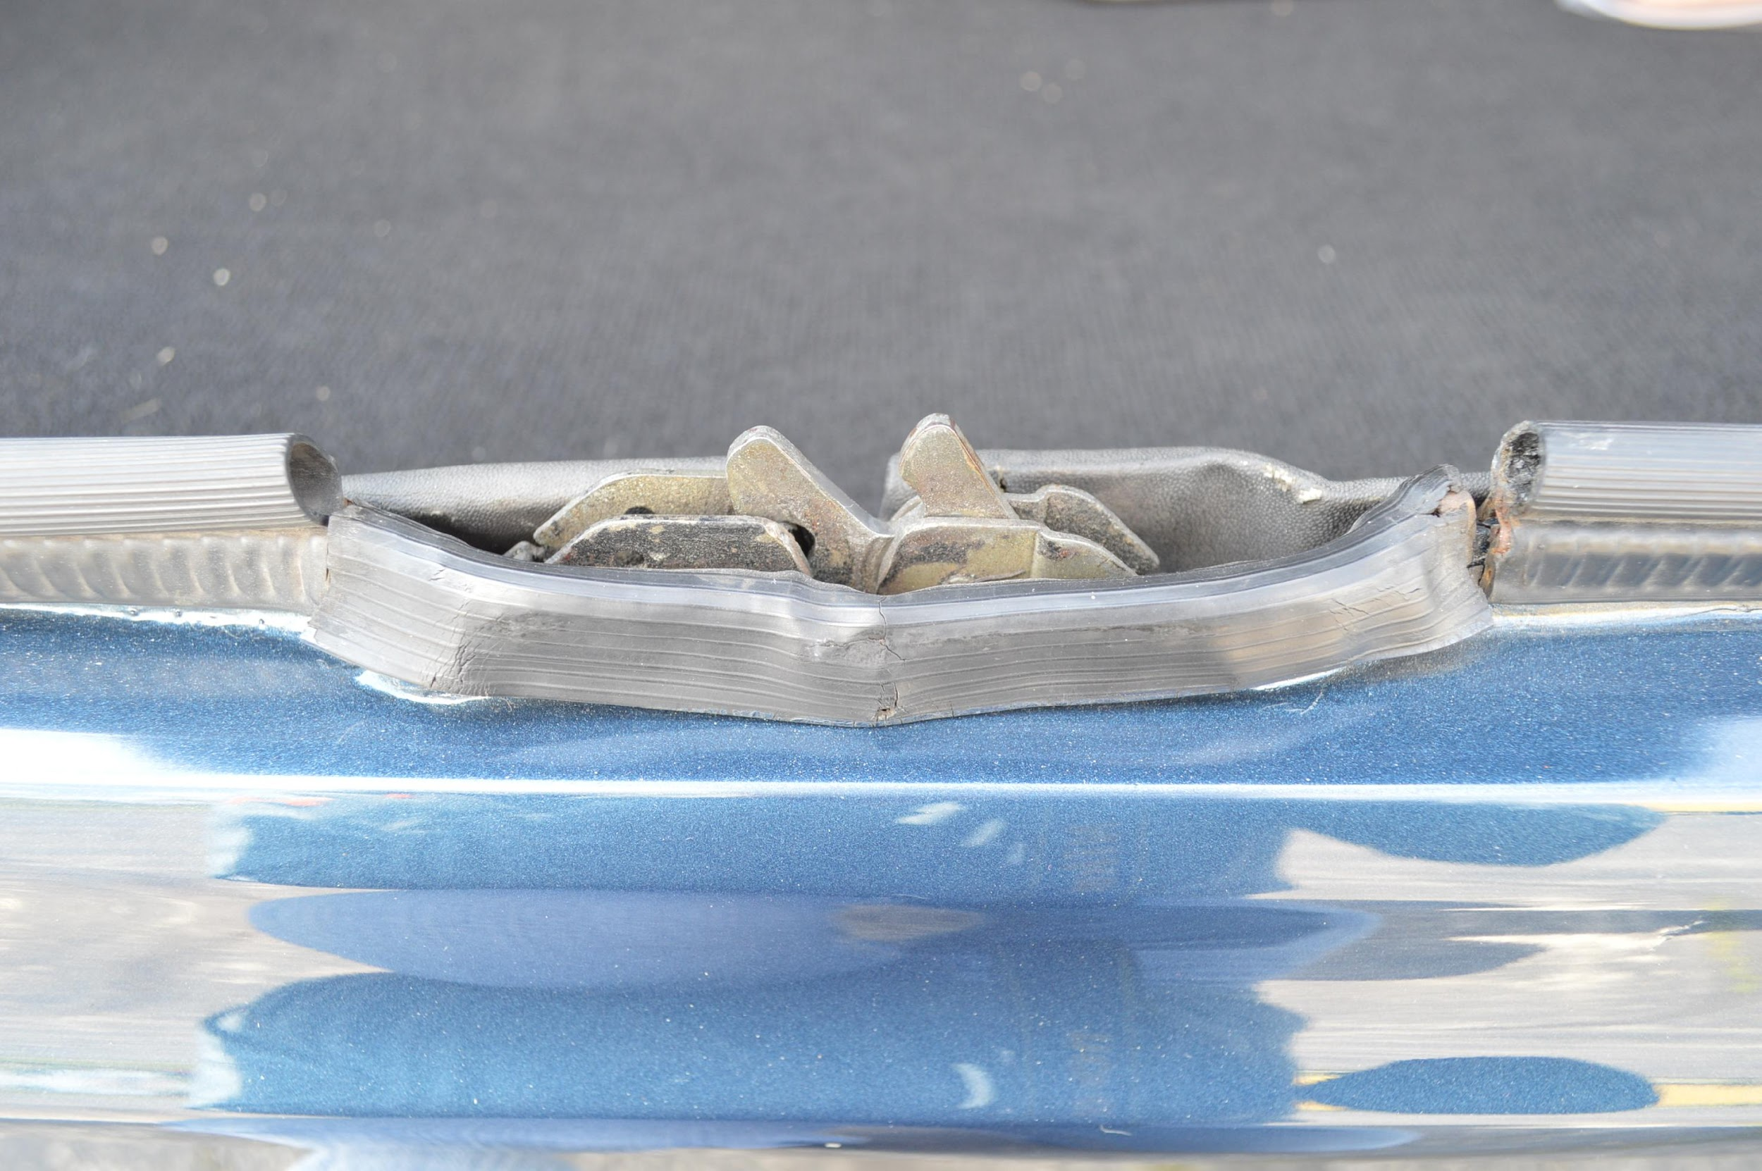46. Functional trunk latch and moldings. Daytona Speciale. Image Dustin Wetmore
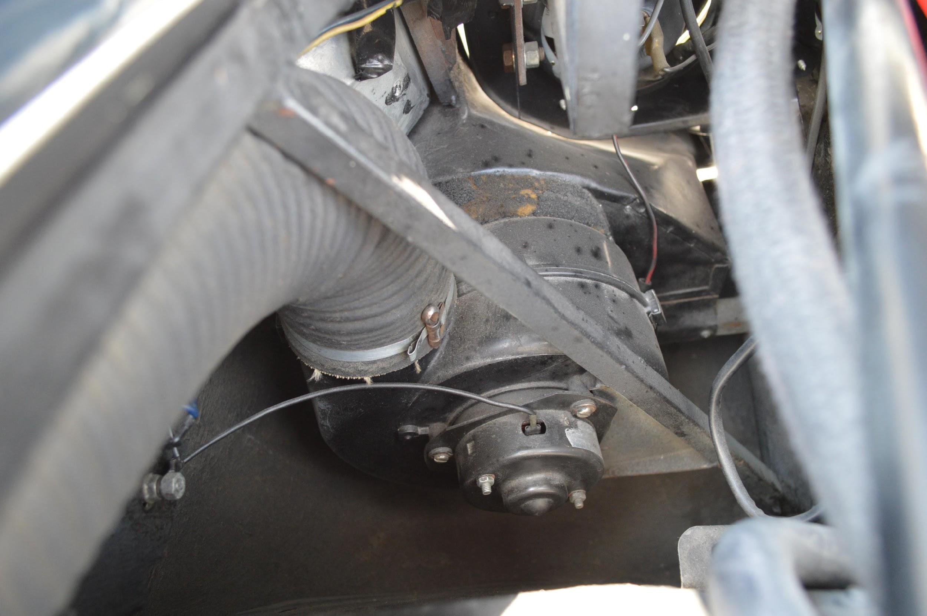47. Untouched heater hose, clamps, motor. and wiring. Daytona Speciale. Image Dustin Wetmore
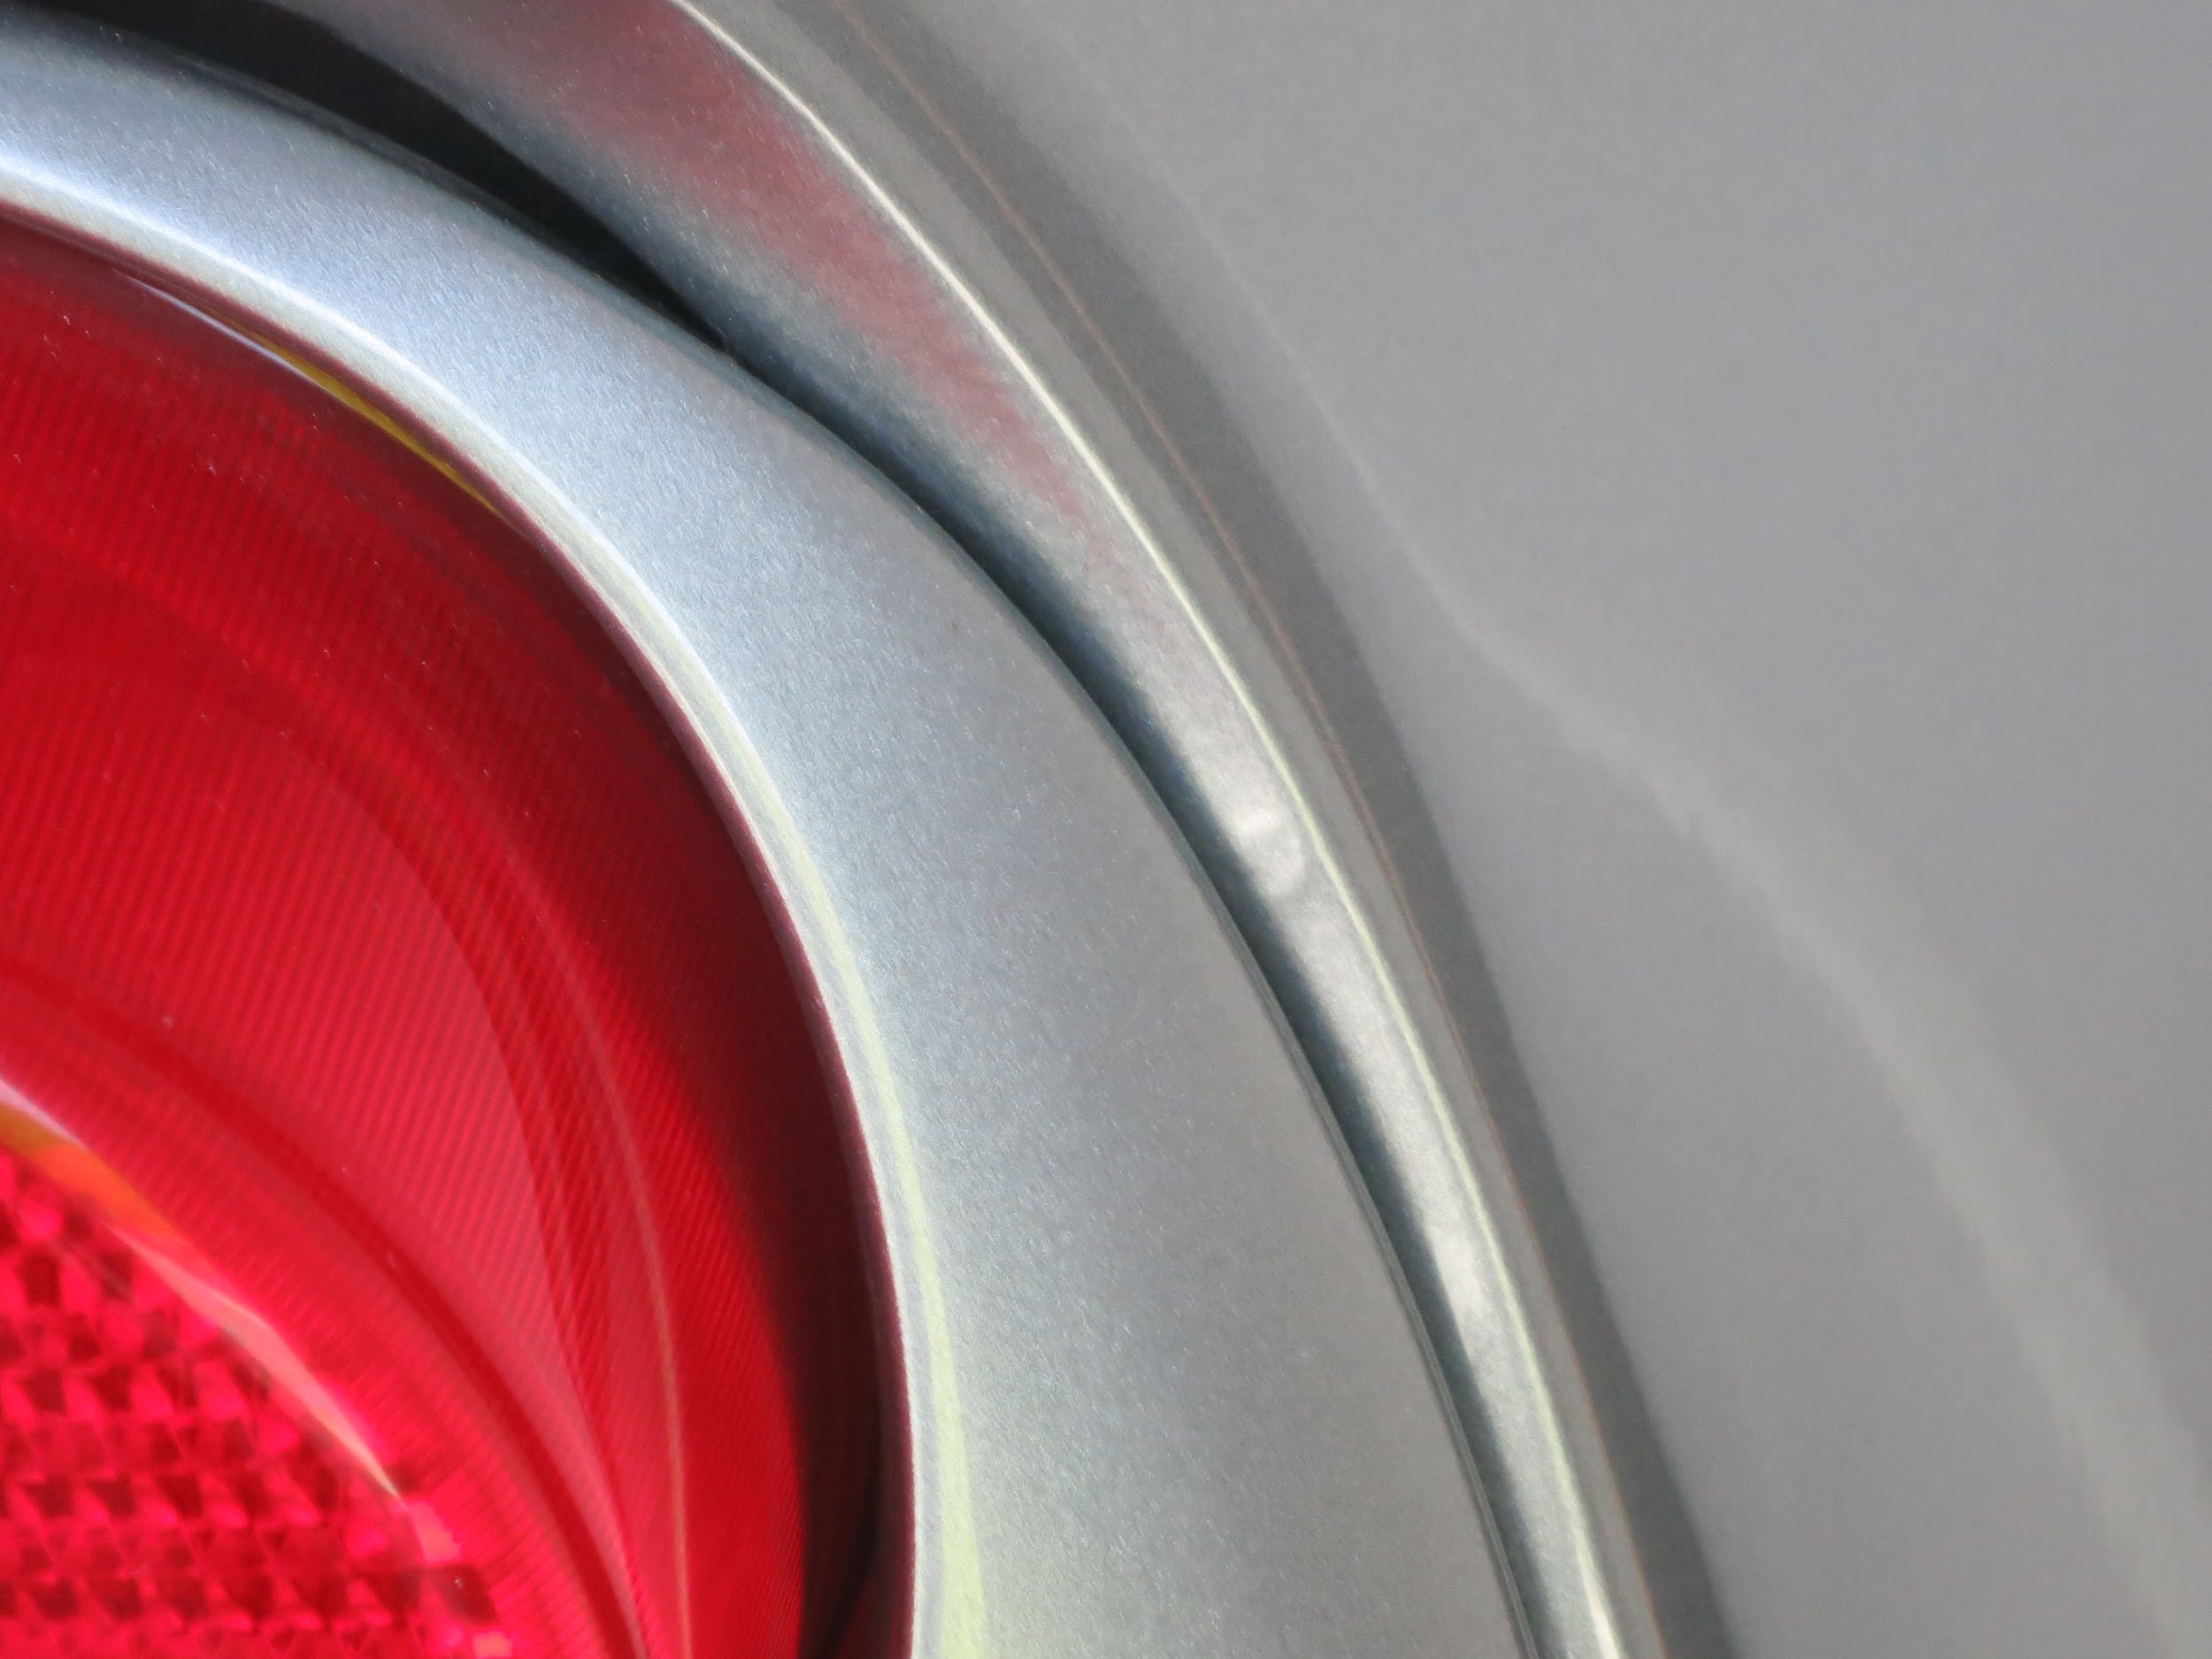
48. Typical factory paint blemish as delivered in unlikely to notice taillight area. Original 355. Image Donovan Leyden

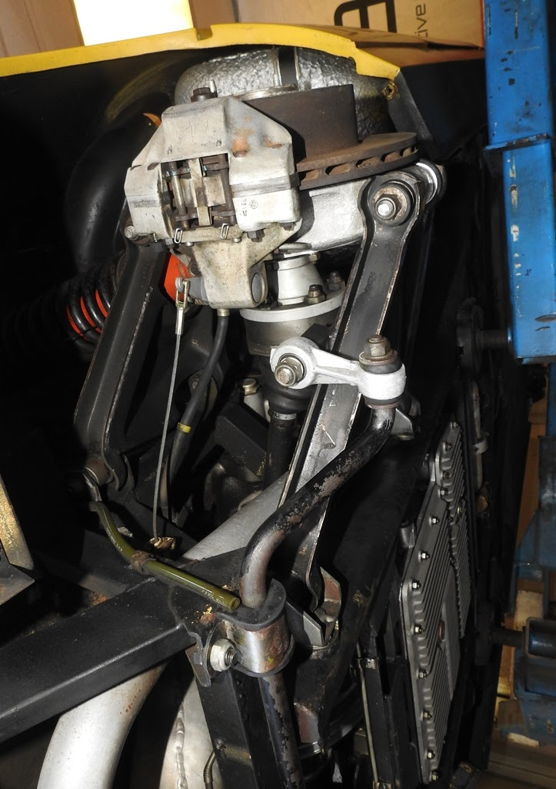
49. Original suspension and brakes with patina and cleaned with cryo. 308. Image Senega Archive/ERS

